 | The CAMECA IMS 7f (*)  ion optics user’s guide (2)  The secondary ion optics  00 45 610 682 - Type 108 – Indice B
0000.doc
(This documentation is relevant for the IMS7f the number of which is equal or larger than 715)
The first part of the ion optics user's guide is contained in another documents, ion optics user's guide (1) dedicated to the primary column.
Aug 08: Modification of the definition of coeff_fa and coeff_ca
Index
Contents
1 (Introduction) 3
2 (The primary column) 3
3 The secondary ion optics 3
3.1 Overview 3
3.2 The Secondary Optics Physical Principles 8
3.2.1 The Immersion lens. 8
3.2.1.1 Overview 8
3.2.1.2 The trajectories in the immersion lens region, the cross-over 9
3.2.1.3 The immersion lens aberrations 9
3.2.1.4 Accelerating mode and decelerating mode 10
3.2.2 The matching transfer ion optics. 11
3.2.2.1 Overview 11
3.2.2.2 The matching transfer ion optics arrangement 13
3.2.2.3 The matching transfer zoom 15
3.2.2.4 Using the immersion lens with the accelerating mode. 16
3.2.2.5 Linking DT1 and DT3 for achieving DT_FA and DT_CA 16
3.2.3 The mass spectrometer 18
3.2.3.1 The double focusing spectrometer principles 18
3.2.3.2 The spectrometer aberrations and the mass resolution issue 24
3.2.3.3 The magnet and the mass calibration issue. 26
3.2.3.4 Magnet settling time 29
3.2.4 Dynamic transfer and electronic gating 30
3.2.4.1 Dynamic transfer 30
3.2.4.2 Electronic gating, BBS 30
3.2.5 The Detection system 32
3.2.6 The MCP Direct imaging (Projection line) 32
3.3 Tuning the secondary ion optics 35
3.3.1 Overview 35
3.3.2 Routine secondary ion optics check of an existing ISF (operator level) 35
3.3.3 Building new secondary presets 40
3.3.4 Miscellaneous Tuning 43
3.3.5 The Mass Resolution and Aperture presets 44
3.3.6 Modifying the Secondary voltage (Sple HV) 46
4 Secondary Ion Detectors 47
4.1 Direct ion image detector (Microscope mode) 47
4.1.1 Microchannel plate/ Fluorescent screen (MCP/FS). 47
4.1.2 Resistive anode encoder (RAE). 50
4.2 Ion detectors for counting mode. 50
4.2.1 Faraday cup (FCs) 51
4.2.1.1 The FCs channel description 51
4.2.1.2 The FCs channel resolution and thermal drift 51
4.2.1.3 The FCs Channel settling time, definition of N_{faraday} . 52
4.2.2 Electron multiplier (EM) 53
4.2.2.1 Principles 53
4.2.2.2 EM output and discriminator threshold 53
4.2.2.3 Dead time and Yield corrections. Dependance on the gating 55
4.2.2.4 EM aging 56
4.2.2.5 The EM electronic dead time adjustment 57
4.2.3 Switching EM/FCs and FCs/EM 57
5 The Depth Profiling issue 58
5.1 Overview 58
5.2 Electronic gating 61
5.3 Optical gating 62
5.4 The η_{gate} gate rate 63
6 Controlling the ion optics from the computer 64
6.1 Overview 64
6.2 The Instrument Status Files (ISF) 65
6.3 Main Analytical Parameters (MAP) and Optional Instrument Parameters (OIP) 65
6.3.1 Other presets 66
6.4 The Set-up files 66

Contents ↑

(Introduction)
(Refer to the ion optics user's guide (1)/Introducton )

(The primary column)
(Refer to the ion optics user's guide (1)/The Primary column )

The secondary ion optics

Overview
The IMS-7f and 4fE7 secondary optics are quite identical to the previous Cameca IMS 3-4-5-6f, but it is somewhat different of the IMS Wf and SC-Ultra, especially the section comprised between the sample plane and the last transfer lens.
The IMS-7f and 4fE7 secondary optics consists of
- The matching transfer optics consisting of a set of lenses purposed to "match" the emitted secondary beam to the mass spectrometer, i.e. to fill properly both mass spectrometer entrance apertures, the Entrance Slit and the Field Aperture.
- The double focusing mass spectrometer, basically consists of a magnet, dispersing two different ion mass trajectories, and an electrostatic sector (ESA), cancelling the magnet energy dispersion which is a counterpart of the mass dispersion. In combination with the magnet, an Exit Slit allows to filter a narrow mass band [M-ΔM/2, M+ΔM/2 ]
- The ion counting detection system, located just after the Exit Slit, and consisting of an electron multiplier (EM) and a Faraday cup (FCs).
- The projection ion optics, also located just after the Exit Slit, and used alternatively with the ion counting detection system, purposed for projecting either the ion sample image or the Exit Slit plane image onto a microchannelplate device (MCP). A CCD camera allows to display these images on a video monitor.

The secondary ion optics can be considered as a mass filtered ion microscope since the sample plane image is transferred all along the secondary optics and can finally be displayed in the MCP plane.
The secondary ion optics can also be considered as the detection device of a Scanning Ion Microscope (SIM) since a so-called dynamic transfer (DT) deflection device, synchronized with the primary raster signal allows to collect the secondary ions from a sputtered area as large as 500x500 µm.
It is explained in the section § the Depth Profiling issue, that both capabilities, ion microscope and SIM are used for performing Depth Profile analyses

Implementation
The next figure displays a schematic showing the computer controlled devices and all the apertures. Some comments about all these devices are given further.
All the physical principles and concepts involved in the secondary optics are then more precisely discussed in the section § The Secondary Optics Physical Principles. And finally, some guidelines are given for tuning the secondary optics ex nihilo or just for checking that the secondary beam is suitable for a given job.

Secondary optics schematic
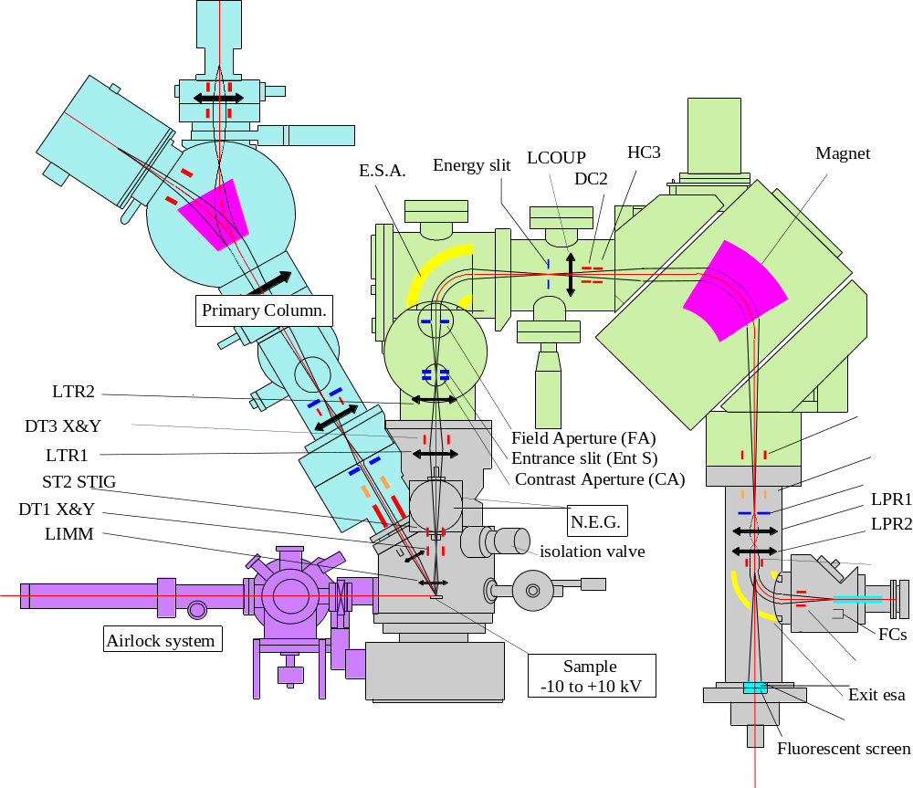

Contents ↑

Description of the secondary optics

Device Label | Functional Labels | Functionality
Sample stage | SAMPLE HV | Sample stage biased at High Voltage (Sample HV). Both the Last Lens last electrode and the immersion lens first electrode are also biased at Sample HV.
Immersion Lens | LIMM | Electrostatic immersion lens consisting of the acceleration space comprised between the sample plane connected to secondary HV and the front grounded plate and a conventional einzel lens the external electrodes of which are grounded. It plays both roles of secondary ion acceleration and ion microscope objective lens.
Dynamic transfer DT1 | DT-FA  DT-FA  DT Raster X  DT Raster Y | This device consisting of two pairs of deflection plates is approximatively located at the immersion lens pupil plane. See below the section § Linking DT1 and DT3 for achieving DT_FA and DT_CA  A fast Raster signal, synchronized with the primary raster can be driven on the device. In addition to the fast Raster signal, a static centering is also implemented onto this device. Dynamic or static deflection move the beam in the Field Aperture plane. See below the section § Dynamic transfer and electronic gating.
Stigmator ST2 | STIG s1  STIG s2 | 8 pole device controlled as a stigmator.
Transfer lens  LTR1 | LTR1 | Electrostatic lens forming the matching transfer optics in combination with the immersion lens LIMM and LTR2.
Deflector  DT3 | DT CA X  DT CA Y | This device consisting of two pairs of deflection plates is located between transfer lenses LTR1 and LTR2. It is purposed to align the beam with respect to the contrast aperture CA.  See below the section § Linking DT1 and DT3 for achieving DT_FA and DT_CA
Transfer lens  LTR2 | LTR2 | Electrostatic lens forming the matching transfer optics in combination with the immersion lens LIMM and LTR1.
Contrast Aperture CA | CA X  CA Y | One among 4 stops located on a movable bar can be selected and centered onto the secondary axis. Normal diameters are 400µm, 150µm, 50µm and 20µm. The smaller the diameter the better the lateral resolution of the sample surface image in the microscope mode.  The bar is driven manually or, in the case of motorized option, by 2 stepping motors (X & Y). The 4 stops are placed along the Y axis.
Entrance Slit | ENT SL X  ENT SL W | Slit with edges parallel to the Y axis, are attached to a deformable ring. Pressing the ring opens the slit and allows to vary the slit width from 0 to 400µm. In the case of motorized option, it is driven by 2 stepping motors, for the X centering and for the W adjustment. A small width is required for a high mass resolution (See below the section § The double focusing spectrometer).
Field Aperture | FA X  FA Y | One among 4 stops located on a movable bar can be selected and positioned on the secondary axis. Normal diameters are 1800µm, 1200µm, 750µm and 400µm. A small diameter is required for a high mass resolution (See below the section § The double focusing spectrometer).  In the case of motorized option, the bar is driven by 2 stepping motors (X & Y). The 4 stops are placed along the Y axis.
Spectro ESA | ESA1 | Spherical electrostatic sector. Its radius is 85 mm. Controlled by a single variable which is the average between the absolute value of its 2 electrode voltages (See the Basic ion optics user's manual/ ESA) . Forms the image of the Entrance Slit in the Energy Slit plane.  (See below the section § The double focusing spectrometer).
Energy Slit | ENER SL X  ENER SL W | Aperture consisting of 2 movable edges LE (Low Energy) and HE (High Energy). In the case of motorized option, the motion axis is Ox. Both egdes are controlled by variables X and W:  LE Position = X  HE Position = X + W
Coupling Lens | LCOUP | Electrostatic lens purposed for achieving the spectrometer achromatism in combination with the ESA and the Magnet (See the section § The Double Focusing Spectrometer)
Deflector DC2 | DC2 Y | (In the case of hexapole option) deflector used to center the beam within the magnet tube.
Hexapole HC3 | HC3 | (In the case of hexapole option) Hexapole tuned for minimizing the spectrometer second order aberrations.
Magnet | Mass | Magnet controlled directly from the operator keyboard.  (See the sections § The Double Focusing Spectrometer and § The magnet and the mass calibration issue)
Quadrupole  DSP1 | DSP1 DX  DSP1 DY  SLIT STIG  BBS | 4 plate multipole with 4 implemented functions:  - A Beam centering in X and Y  - An X/Y stigmator  - A fast beam-blanking BBS
Image Stigmator | IMA STIG s1  IMA STIG s2 | 8 poles sigmator used for improving the sample image (in the projection image mode) and for adjusting the parallelism of the entrance slit image with respect to the exit slit.
Exit Slit | EXIT SL W | Slit with edges parallel to the Y axis are attached to a deformable ring. Pressing the ring opens the slit and allows to vary the slit width from 0 to 1500µm. In the case of motorized option, driven by one stepper motor for the W adjustment. The X centering can be adjusted manually. A small width is required for a high mass resolution (See below the section § The double focusing spectrometer).
Proj Lens LPR1 | LPR1 | Electrostatic lens. In combination with LPR2, it forms the projection zoom, allowing to project onto the MCP plane either an ion image of the sample plane or an ionic image of the beam section at the exit slit plane.
Proj Lens LPR2 | LPR2 | Electrostatic lens. In combination with LPR1, it forms the projection zoom, (See above, LPR1)
MCP deflector | MCP X  MCP Y | 4 plate deflector used for centering the beam within the MCP.
Exit ESA | EXIT ESA | Spherical Electrostatic sector. When biased, it switches the ion beam toward the detection stage. When not biased, a hole allows the beam to go straight forward to the MCP plane.
Switch FC/EM | EM-DY  FC-DY | 2 plate deflector located just after the exit ESA, allowing to switch the beam either into the Faraday cup, or onto the EM first dynode. As the EM is on-axis, the voltage corresponding to the EM is close to zero.
EM | EM HV  EM THRES  DET PA HV | Electron Multiplier used for ion counting (See the section § The Electron Multiplier).
FCs | FDY RPL | Faraday cup is used for measuring the secondary ion current in the Faraday mode, i.e. directly. The Faraday Repeller (FDY RPL) is a plate located just before the Faraday cup for repelling the secondary electrons generated by the secondary ion impact in the Faraday cup.
MCP | MCP  CP SCINT | Ion image intensifier consisting of a MicroChannelPlate and a Phosphorus screen biased with respect to the MicroChannelPlate (CP SCINT)- See the section § The Microchannel Plate - The MicroChannelPlate voltage (i.e. gain) is controlled directly from the operator keyboard.

Contents ↑

The Secondary Optics Physical Principles

The Immersion lens.

Overview
The immersion lens is the objective of the matching transfer optics, (See the following section § the matching transfer ion optics). As it can be read in the user's guide § Basic Ion Optics/ Electrostatic Lenses, the immersion lens is formed by all the spaces between the sample and the last grounded electrode.
A schematic of the immersion lens region is displayed in the next figure. As it can be seen, the part of the primary trajectory located just before the sample is strongly immersed in the secondary extraction field. For the consequences of this interaction refer to the Primary column ion optics user's guide/ The landing issue .

The immersion lens region

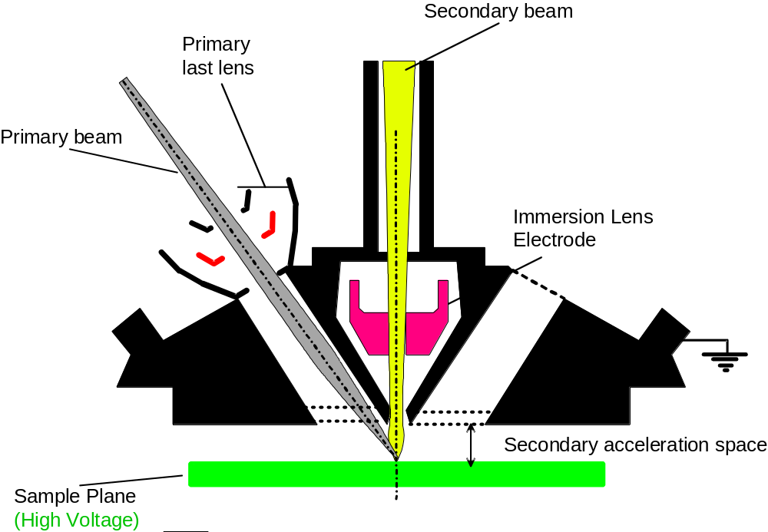

Contents ↑

The trajectories in the immersion lens region, the cross-over

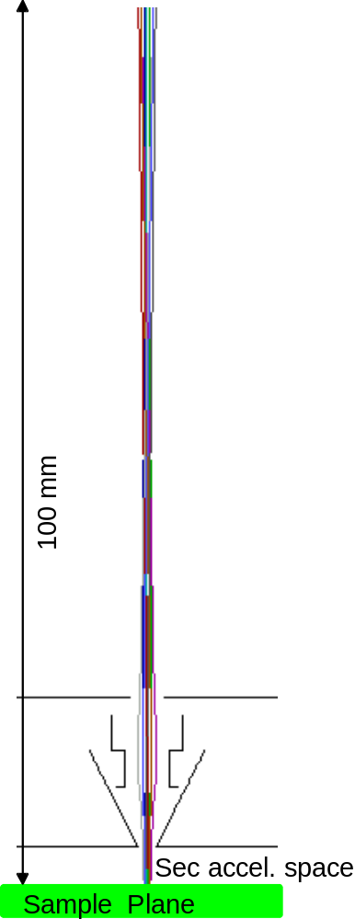 | 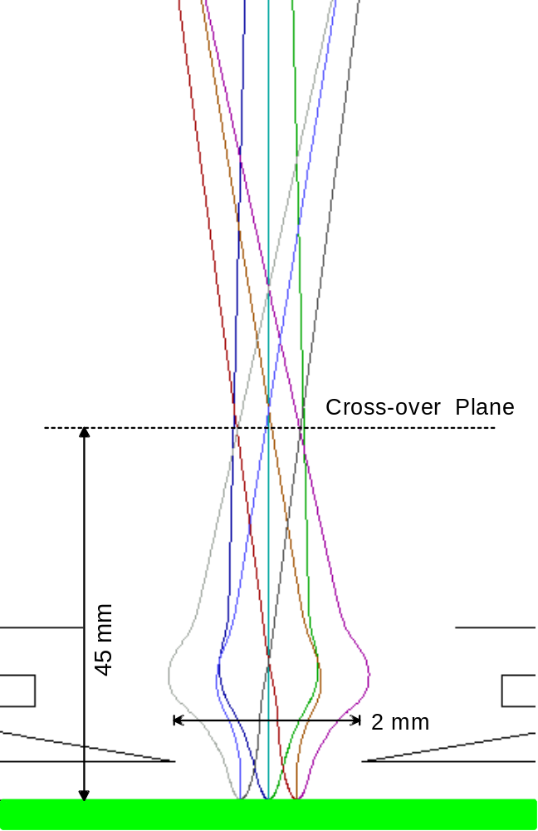
The secondary trajectories at scale 1:1 | The secondary trajectories scaled up along the x axis.  All trajectories coming from different sample points but with the same lateral energy converge at the so-called cross-over plane.

The immersion lens aberrations
Both the Recknagel chromatic aberration and the spherical aberration are presented below. For extrapolating the displayed data to other conditions, it must be said that

- Spherical aberration is proportional to α³, α being the beam aperture angle at the sample plane.
- Recknagel chromatic aberration is proportional to 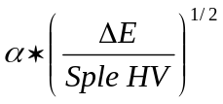

Both aberrations must be summed in quadrature.

The user cannot know directly α. It must therefore pointed out that α is proportionnal to 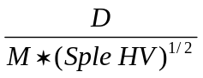, where D is the contrast aperture (CA) diameter so far the CA is limiting the beam, and M is the sample image magnification in the Field Aperture (FA) plane. (for further explanations about CA, FA, M, refer to the hereunder sections § The matching transfer ion optics and § The matching transfer zoom)

ΔE is limited by the energy slit, but within the energy slit, the energy distribution is not constant. It also depends on the nature secondary ions (narrower distribution for molecular ions). Typically, for a monoatomic ion, it can be said that 50% of the beam is contained in a 15eV window and 90% of the beam is contained in a 35 eV window.

Immersion lens aberration for typical conditions:
(Sample HV=5000V, CA=150 µm, M=12, i.e. α=0.0125)

 | ΔE=5eV | ΔE=10eV | ΔE=20eV
Spherical aberration (µm) | 3 | 3 | 3
Recknagel aberration (µm) | 4 | 6 | 8

Note that when selecting the larger contrast aperture, if the cross-over diameter is, for example, 300µm width, the spherical aberration is multiplied by 8 and becomes the dominating aberration.

Accelerating mode and decelerating mode
For leading to the same focal length, the immersion lens, as any lens, may be fired either with a so-called decelerating mode or with a so-called accelerating mode.
- With the decelerating mode, which is actually the regular mode, the immersion electrode is biased in the same polarity as the sample voltage. The ions are therefore decelerated when passing through the lens.
- On the contrary, with the accelerating mode, the immersion electrode is biased in the polarity opposite to the sample voltage. The ions are therefore accelerated when passing through the lens.

The accelerating mode is more advantageous since the spherical aberrations and some chromatic aberrations are reduced by a factor close to 2. Unfortunately, as it is explained in the following section, with the accelerating mode the electrode voltage amplitude must be larger than with the decelerating mode, typically 2.5 times the secondary voltage. Taking into account the fact that this lens may be the source of arcing if the electrode voltage is larger than 7000 Volts, the accelerating mode must be limited to secondary voltages smaller than 2.5 kV.
Contents ↑

The matching transfer ion optics.

Overview
The secondary SIMS ion source can be featured as an emitting area at the sample plane and an angular emitting diagram. The emitting area is mainly determined by the primary ion probe, while its intensity and its angular diagram is mainly determined by SIMS processes (See A.Benninghoven et al. Secondary Ion Mass Spectrometry, John Wiley & Sons, 1987, § 2.2.5, Secondary ion emission)
A mass spectrometer entrance consists of a pair of apertures, the Entrance Slit, which limits the beam area, and the Field Aperture (FA), which limits its angular aperture. (See the section § Mass Spectrometer)
The so-called Matching Transfer ion optics system is a set of 3 lenses, the immersion lens and two other transfer lenses (LTR1 and LTR2). This ion optics system is purposed to match the secondary ion source to the mass spectrometer entrance.

Coarsely, the matching transfer ion optics of the IMS 7f and 4fE7 produces a sample image within the Field Aperture plane, while the angular diagram is imaged at the Entrance Slit plane, or more precisely, a lateral energy diagram is formed at the entrance slit plane. This region of the beam, imaged at the entrance slit plane is so-called the "Cross-over" since it corresponds to the smallest beam cross-section. The size selection of both the field aperture and the entrance slit is described in the section § The spectrometer aberrations and the mass resolution issue. See the sample images as they are formed in the MCP plane in the section § Checking existing ISF .
Additionally to the entrance slit and the field aperture, another aperture located very close to the entrance slit, the so-called Contrast Aperture (CA) is used for limiting the lateral energy in order to get a better lateral resolution when forming the sample image in the ion microscope mode. 4 different diameter apertures can be selected: 400µm, 150µm, 50µm and 20µm. The effect of this CA is to limit the immersion lens aberrations (see above the section § The immersion lens aberrations)
The matching transfer optics arrangement details are described below in the sections § the matching transfer ion optics arrangement and § The matching transfer zoom. Practically the user has to select a sample image magnification. It must be clear that the respective magnifications of both the sample image and the cross-over are balanced: Increasing the sample image size leads to decrease the cross-over diameter. According to each specific application, the zoom selection will be achieved with respect to the following considerations:
- Optical gating: The field aperture is then used for selecting in the sample image a limited area to be analyzed. (See the section § The Depth Profiling issue/ Optical gating.)
- Transmission optimization: As it is explained in the section § The Mass spectrometer, both the FA and the Entrance Slit are determined for a given mass resolution. At a given mass resolution, if the beam cross section within the FA (i.e. the sample image) is smaller than the FA, it is then recommended to set the transfer zoom in order to fully fill the FA with the beam and to reduce therefore its diameter within the entrance slit which will be better in terms of transmission.
When the ion beam diameter is enlarged in the FA plane, it is reduced in the entrance slit plane

Contents ↑

The matching transfer ion optics arrangement

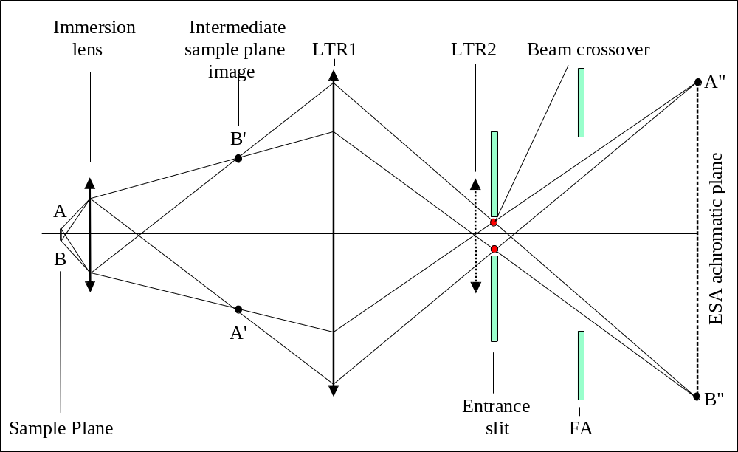

On the above figure, the trajectories are displayed in the case when only the lens LTR1 is biased. It corresponds to a sample image magnification (A"B"/AB) of 7.2 in the FA plane. For instance a FA of 1800 µm yields to a field of view at the sample surface of 250µm. In fact, the sample image must not be formed exactly in the FA plane but in the so-called ESA achromatic plane which is coarsely located at the ESA center plane.
It is explained in the section § Tuning the secondary optics that in a first step, it can be more convenient to focus the sample image exactly in the FA plane so that when observing the MCP image in the ion microscope mode (see the section § The MCP direct imaging), both the FA image and the sample image A"B" are focused at the same time. Nevertheless, this configuration has a drawback: Because of the sample image not focused in the achromatic plane of the ESA, if there is a slight shift in the magnet setting this shift will lead to an image shift onto the MCP detector which can cause an error if the ion microscope image is used for centering the primary beam.
On the contrary, if focused in the ESA achromatic plane, the sample image A"B" is unsensitive to a slight magnet shift. This focusing is obtained by an immersion lens focusing small variation which is not so difficult to tune with the criterion of getting a fix image when varying slightly the magnet.
The drawback of this tuning (focusing the sample image not in the FA plane but in the ESA plane), is a poorer cutting power of the FA in the optical gating mode, due to the sample image blurring in the FA plane. This drawback which can be generally accepted is discussed in the section § The depth profiling issue/optical gating.
The above optical sketch is still valid when LTR2 is biased ?. The transfer lens position variation leads to a variation of the sample image magnification: 94 instead of 11.1
While the cross-over diameter is typically of 300µm when using the single lens LTR1, it is as small as 40 µm when using the single lens LTR2. This last configuration is actually rarely used since the size of the sample area contained in the largest FA, 20 µm, is of the same order of magnitude as the immersion lens aberrations.
Fortunately, using a combination of both LTR1 and LTR2 allows to obtain all the intermediate magnifications between 7.2 and 60. (See the next section.)

Contents ↑

The matching transfer zoom
The first table displays the focal length configurations corresponding to the transfer zoom different magnifications. The second table displays the lens voltages, assuming that the sample voltage if of 5 kV, and the last table displays these voltage in Tuning digits, assuming that 4096 digits correspond to 10443 volts.
Lens focal lengths
Sample image  magnification  in FA plane | Sample Field  contained  in FA=1800µm  (µm) | Immersion lens  (mm) | f(LTR1)  (mm) | f(LTR2)  (mm)
5.6 | 320 | 20.66 | 93.0 | 300.0
7.2 | 250 | 21.79 | 94.6 | 87.0
9.0 | 200 | 22.51 | 97.6 | 52.0
12.0 | 150 | 23.00 | 103.0 | 35.5
18.0 | 100 | 23.13 | 118.2 | 26.2
24.0 | 75 | 23.04 | 138.2 | 23.0
57.2 | 31 | 22.57 |  | 19.1

Lens Voltages (for Sample HV=5000V)
Sample image  magnification  in FA plane | Sample Field  contained  in FA=1800µm  (µm) | Immersion lens  electrode  (Volts) | V(LTR1)  (Volts) | V(LTR2)  (Volts)
5.6 | 320 |  | 2985 | 1629
7.2 | 250 | 3497 | 2965 | 2684
9.0 | 200 | 3474 | 2928 | 3271
12.0 | 150 |  | 2866 | 3773
18.0 | 100 |  | 2713 | 4222
24.0 | 75 |  | 2549 | 4403
45.0 | 40 |  | 0 | 2201

Lens Digits (for Sample HV=5000V)
Sample image  magnification  in FA plane | Sample Field  contained  in FA=1800µm  (µm) | Immersion lens  electrode (1)  (Digits) | V(LTR1)  (Digits) | V(LTR2)  (Digits)
5.6 | 320 |  | 1171 | 639
7.2 | 250 | 22178 | 1163 | 1053
9.0 | 200 | 22028 | 1148 | 1283
12.0 | 150 |  | 1124 | 1480
18.0 | 100 |  | 1064 | 1656
24.0 | 75 | 21183 | 1000 | 1727
45.0 | 40 | 22136 | 0 | 1850
(1) 65536 digits correspond to 10334 Volts
Contents ↑

Using the immersion lens with the accelerating mode.
As it is explained above, § Accelerating mode and decelerating mode, it is more advantageous to use the immersion lens with the accelerating mode whenever the secondary voltage is smaller than 2.5 KV. In this case, the setting of the immersion lens are listed in the hereunder table.

Lens Voltages (for Sample HV=2500V)
Sample image  magnification  in FA plane | Sample Field  contained in FA=1800µm  (µm) | Immersion lens  electrode  Decel mode  (Volts) | Immersion lens  electrode  Accel mode  (Volts) | LTR1  (Volts) | LTR2  (Volts)
5.6 | 320 | 0 | 0 | 0 | 0
7.2 | 250 | 0 | 0 | 1833 | 0
9.0 | 200 | 1752.5 | 6087 | 1821 | 1212
12.0 | 150 | 0 | 0 | 1804 | 1550
18.0 | 100 | 2232 | 5830 | 1769 | 1829
24.0 | 75 | 0 | 0 | 1670 | 2085
45.0 | 40 | 0 | 0 | 1571 | 2194

Linking DT1 and DT3 for achieving DT_FA and DT_CA
Both deflectors of the transfer line can be linked so that DT_FA moves the beam in the FA plane while keeping it fixed in the CA plane and DT_CA moves the beam in the CA plane while keeping it fixed in the FA plane. The link coefficients for this purpose can be edited and tuned in the Tuning Max Area preset, according to the relationship
dt_fax = dt1x + coef_cax dt3x
dt_fax = dt1y + coef_cay dt3y
dt_cax = coef_fax dt1x + dt3x
dt_cay = coef_fay dt1y + dt3y

Where dt1x&y is the deflector located downwards the immersion lens, and dt3x&y is deflector located between both transfer lenses.

As a consequence of the definition, the physical deflections DT1 and DT3 depend on the parameters dt FA and DT CA as follows:
dt1x=(dt_fax - coef_fax*d_cax)/(1 – coef_cax*coef_fax)
dt1y= (d_fay - coef_fay*d_cay)/(1 – coef_cay*coef_fay)
dt3x=(d_cax - coef_cax*d_fax)/(1 – coef_cax*coef_fax)
dt3y=(d_cay - coef_cay*d_fay)/(1 – coef_cay*coef_fay)

The way of setting both pairs of coefficient is:
coef_fax must be tuned so that when dt_cax is varied, the beam is not shifted in the FA plane.
coef_cax must be tuned so that when dt_fax is varied, the beam is not shifted in the CA plane.
and the same for coef_fay and coef_cay.

The practical procedure for tuning coef_fax (or coef_fay) consists of setting DT_FA and DT_CA to zero, to observe the FA plane, and to vary DT_CA. If the beam is observed to be shifted in the FA plane, then tune coef_fax (or coef_fay) in order to bring back the beam to its first location. Then, valid the preset.

Respectively, the practical procedure for tuning coef_cax (or coef_cay) consists of setting DT_FA and DT_CA to zero, to observe the CA plane, and to vary DT_FA. If the beam is observed to be shifted in the CA plane, then tune coef_cax (or coef_cay) in order to bring back the beam to its first location.

Note that, when the coefficients are set to zero, the main effect of DT1 is to move the beam in the FA plane and the main effect of DT3 is to move the beam in the CA plane. Then, valid the preset.

The parameters which are activated by the operator are actually integers equal to the coefficients coef_fa and coef_ca multiplied by 1000. These coefficients are depending on the Max area preset
Typical values
Max area | coef_fa X or Y | coef_ca X | coef_ca Y
250 µm | -270 | -1000 | 1000
150 µm | 135 | -1200 | 1200
75 µm | 175 | -2800 | 2800
40 µm | 105 | -4500 | 4500
coef_ca X and coef_ca Y may also be set to zero without significant counterpart on the alignment routines.

Contents ↑

The mass spectrometer

The double focusing spectrometer principles
Mass dispersion and Energy focusing principle
The double focusing mass spectrometer includes first a magnet which produces the magnetic field required for dispersing the beam in mass according to the relationship.
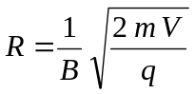
Which can be also written in more practical units, for a monocharged ion
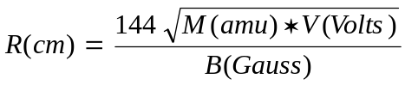
Where
R is the trajectory curvature radius (11.7cm for the IMS 7f and 4fE7)
M is the atomic mass of the considered ion.
B is the magnetic field produced by the magnet along the ion path
V is the ion secondary accelerating voltage

This relationship shows that the magnetic field is also energy dispersing. The secondary ion energy spread can be as large as several tens of eV. If the spectrometer were consisting of a single magnet, a mass spectrum peak would be completely blurred by this energy dispersion, leading to a very poor mass resolution. Compensating the magnet energy dispersion by an electric field produced by an electrostatic sector analyser (ESA) is the basic principle of a double focusing spectrometer. The electric field energy dispersive effect is driven from the non-mass dependent basic relationship:
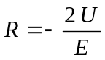
where R is the trajectory curvature radius (8.5cm for the IMS 7f and 4fE7)

For achieving the cancellation of the energy dispersion, an electrostatic lens, called coupling lens or spectrometer lens is added between the ESA and the magnet. The figure a of this section shows how the energy focusing is obtained with this arrangement: The 3 trajectories (yellow, red and blue) correspond to 3 different energies. They are primarily dispersed by the ESA. The electrostatic lens then inverts their dispersion angle, so that the magnet energy dispersion cancels completely the ESA dispersion.

Energy filtering
It can be seen in the figures b and c that an energy slit is mounted before the coupling lens, in the region where the energy dispersion is maximum, allowing to select in the beam an energy window. The energy dispersion at the energy slit is given by
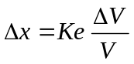

Where Δx is the distance between the axis and the trajectory corresponding to an acceleration voltage of V+ΔV, K_{e} is the energy dispersion coefficient (170mm for the IMS 7f and 4fE7) and V is the axis ion acceleration voltage.

Figure a: The energy focusing sketch

Imaging capability of electrostatic and magnetic sectors
In addition to their mass and energy dispersing properties, magnets and ESA have focusing properties that are described in the appendix. In particular, a spherical ESA, as it is implemented in the IMS is equivalent to a stigmatic lens, and a suitably shaped magnet, as it is in the IMS is equivalent to a quasi-stigmatic lens (See the Basic ion optics user's guide).
These imaging properties make therefore possible to transfer both the entrance slit and the sample images. This is explained below.

The entrance slit is imaged in the exit slit plane
The figure b shows the overall arrangement of the double focusing mass spectrometer and displays the sketch of a monoenergetic beam:

The entrance slit is imaged by the spherical ESA at scale -1:1 in the energy slit plane.
The coupling lens produces a virtual image of this entrance slit image at scale 1.5:1
This virtual image is imaged by the magnet at scale -1:1 in the exit slit plane

Finally, it results that the entrance slit is imaged at scale 1.5:1 in the exit slit plane.

The sample is imaged in the magnet achromatic plane
The magnet achromatic plane is located approximatively at the magnet center (see the appendix for the meaning of "achromatic plane"). The figure a shows that the double focusing spectrometer arrangement implies that both ESA and magnet achromatic planes are conjugated with respect to the coupling lens.

In the figure b, the different trajectories A, B, C... corresponds to different points A, B and C of the sample. Providing that the matching transfer optics has imaged the sample at the ESA achromatic plane, the sample is finally image at the magnet achromatic plane.

The double focusing spectrometer produces the entrance slit image in the exit slit plane, at scale 1.5:1 and the sample image approximatively at the magnet center plane

The figure c shows a more complete sketch with different angle trajectories coming from the entrance slit and different energies dispersed by the ESA

Figure b: The spectrometer imaging sketch in the case of a monoenergetic beam

figure c: Double focusing spectrometer complete sketch

The spectrometer mass dispersion
Finally, the overall spectrometer produces an entrance slit image at scale X1.5 in the exit slit plane. In this exit slit plane, the mass dispersion is given by

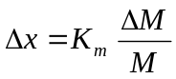
Where Δx is the distance between the M mass trajectory and the (M+ ΔM) trajectory and K_{m} is the mass dispersion coefficient (250mm for the IMS 7f and 4fE7)

Contents ↑

The spectrometer aberrations and the mass resolution issue

Second order aberrations
In the previous section, it was pointed out that the entrance slit was imaged at scale 1.5:1 at the exit slit plane. In this section it will be emphasized that the 1.5:1 entrance slit image is blurred by aberrations whenever the Field Aperture (FA) is larger than 400 µm and the energy slit is larger than 170 µm (i.e. 5eV at 5000V), so far these apertures are actually filled by the beam.

The blurring is given by the set of all the trajectories which do not cross the FA and the energy slit at their respective center: A trajectory crossing the FA at the point (X, Y) and corresponding to an acceleration voltage V+ΔV, V being the acceleration voltage of the on-axis trajectory, will not be exactly focused at the exit slit plane: It will cross the exit slit plane at a distance ΔX from the trajectory corresponding to X=Y=ΔV=0.

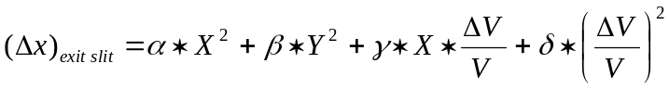

Third order aberrations can be neglected. α,β,γ and δ depend on geometries of the spectrometer different ion optics devices (ESA, coupling lens, Magnet). The hexapole HC3 (in the case of hexapole option) is purposed for minimizing all the set of these second order aberrations.

 | α  (mm⁻¹) | β  (mm⁻¹) | γ | δ  (mm)
HC3=0 | 0.13 | -0.12 | -13.5 | -169
HC3=20 Volts for Sple HV=5000 V | 0.022 | -0.016 | -0.13 | -612

This leads to the following numerical applications for 2 typical cases.

Low Mass Resolution corresponding to FA diameter=1800µm and Energy Slit width=50eV
X=0.9mm; Y=0.9mm, ΔV/V=0.01
 | α ∗ X²  (µm) | β ∗ Y²  (µm) | γ ∗ X ∗ ΔV/V  (µm) | δ ∗ (ΔV/V)²  (µm)
HC3=0 | 103 | -96 | -120 | -17
HC3=20 Volts for Sple HV=5000 V | 18 | -13 | -1 | -62

High Mass Resolution corresponding to FA diameter=750µm and Energy Slit width=20eV
X=0.375mm; Y=0.375mm, ΔV/V=0.004
 | α ∗ X²  (µm) | β ∗ Y²  (µm) | γ ∗ X ∗ ΔV/V  (µm) | δ ∗ (ΔV/V)²  (µm)
HC3=0 | 18 | -17 | -20 | -3
HC3=20 Volts for Sple HV=5000 V | -3.2 | -2.3 | -0.2 | -10

Mass Resolution
The definition of the Mass Resolution (MR) is discussed in the user's manual § Basic Ion Optics/Mass resolution. The IMS 7f and 4fE7 ultimate Mass Resolution is far better than 20000. For obtaining this Mass Resolution, the following settings are recommended

- Exit Slit Width < 10 µm
- Entrance Slit < 5 µm
- FA diameter: 400 µm
- Energy Slit Width < 5eV

The Mass Resolution value, which is displayed in the different application software interfaces, is the Exit Slit Mass Resolution (See the user's manual§ Basic Ion Optics/Mass resolution) , i.e.

W_{Exit Slit}/K_{M}

Practically, the MR depends on both the Exit Slit width and the beam width at the Exit Slit plane (exit beam width). As it is explained in the previous section the exit beam width is the Entrance Slit width multiplied by 1.5 plus the aberrations that depend on the FA diameter and the energy slit width.

Setting the instrument for a high Mass Resolution requires to close all the apertures: Entrance Slit, FA and Energy Slit. This leads to a decrease of the transmitted secondary signal:
In the general case, a compromise must be made between the Mass resolution and the Transmission.

See the Slit MCP images in the section § Routine secondary ion optics check of an existing ISF .
So far a flat top peak is not required (See the flat top peak tutorial in the Basic ion optics user's guide), for obtaining a given Mass Resolution (MR), it is necessary to set both the Exit Slit width and the exit beam width to the corresponding value:

W_{Exit Slit} = K_{M}/MR
W_{Exit} = 2/3 * K_{M}/MR

The FA and the Energy Slit must be selected in order to keep the corresponding aberrations small with respect to the Exit Slit Width.
The user is not supposed to make these calculations, they are included within the Mass Resolution presets so that he has just to click the required MR in the Mass resolution Tuning box or to edit the MR in the Analysis Recipe box.

Tuning preset Mass Resolution

Preset | Label | Entrance Slit  (µm) | Exit Slit  (µm) | FA  (µm) | Ener.Slit  (eV)
1 | 300 | Max | Max | 1800 | Max
2 | 600 | 250 | 400 | 1800 | Max
3 | 1000 | 167 | 250 | 1800 | Max
4 | 1600 | 100 | 150 | 1200 | Max
5 | 2400 | 67 | 100 | 1200 | 50
6 | 3200 | 50 | 75 | 750 | 25
7 | 5000 | 35 | 50 | 750 | 15
8 | 10000 | 15 | 25 | 400 | 10
9 | 25000 | 6 | 10 | 400 | 10

If a flat top peak is required, in a first approach, a straight way is to select the Entrance Slit, the FA and the Energy Slit corresponding to 2*MR and the Exit Slit corresponding to MR

The magnet and the mass calibration issue.
The IMS 7f and 4fE7 magnet coil is supplied within a servoing loop which consists of a Hall probe which measures the magnetic field at a point located close to the magnet center and minimizes the difference between the measured value and the required value B. The actual Mass center onto the exit slit is determined by the magnetic field along the ion path, which is very close to B, but not exactly, depending at high magnetic field on the level of saturation of the magnet pole different regions.
That is why the practical relationship between the required magnetic field B and the selected mass M is

B² = K * k(B) * M * V

Where K is a constant derived from the physical formulas given in the sections § The double focusing spectrometer principles, and k(B) is a coefficient very close to 1. It must be considered that the k(B) table is specific for each instrument and is defined during the factory setting of the instrument.
On the instrument user's interface, B values are not displayed in Tesla, but in digital units, in the range [0, 4194304]. Note that these B values are the command sent to the magnet power supply not an output of the Hall probe system. Therefore if this chassis is Off (or does not properly work) the displayed B field value is different from 0 but there is no field in the magnet. It must be known that approximatively 1 Tesla is required for selecting the ¹³³Cs mass at 5 kV, so that, for the example below, 1 Tesla corresponds to 2 000 000 units.

The[B, k(B)] table
Two [B, k(B)] files are stored in the instrument computer, corresponding respectively to the negative and the positive polarity. Each [B, k(B)] file contains up to 16 points (B, k(B)) and the mass Mmax corresponding to the maximum value of B (2²²=4194304) at V=10 kV An example is given below for building the table with a multilayer InP sample for the positive polarity and a GaAs Mireas sample for the negative polarity.

Sec Positif |  |  |  |  | Sec Négatif
 | M | B | k(B) |  |  | M | B | k(B)
¹H | 1.008 | 178819 | 0.979540 |  | ¹²C | 12.000 | 626051 | 0.993837
³¹P² | 15.487 | 710214 | 0.992434 |  | ¹⁴N | 14.003 | 676758 | 0.994521
³¹P | 30.974 | 1007830 | 0.995989 |  | ¹⁶0 | 15.995 | 722824 | 0.993889
³¹P₂ | 61.947 | 1428876 | 0.998344 |  | ¹⁶0₂ | 31.990 | 1025973 | 0.997530
³¹P₃ | 92.922 | 1753810 | 1.000506 |  | ⁴⁸Ti | 47.947 | 1259347 | 1.000136
¹³³Cs | 132.905 | 2096872 | 1.000243 |  | ⁶⁹Ga | 68.926 | 1511690 | 1.001310
¹³³Cs²⁸Si | 160.880 | 2307849 | 1.000581 |  | ⁷⁵As | 74.922 | 1576358 | 1.001491
¹¹⁵In³¹P₂ | 176.850 | 2419874 | 1.000659 |  | ⁴⁷Ti⁴⁸Ti | 94.899 | 1775226 | 1.002134
¹¹⁵In⁷⁵As | 189.830 | 2506616 | 1.000464 |  | ⁶⁹Ga₂ | 137.860 | 2141918 | 1.003182
¹³³Cs⁶⁴Zn | 196.840 | 2552627 | 1.000522 |  | ⁷⁵As₂ | 149.843 | 2233181 | 1.001311
¹³³Cs¹¹⁵In | 247.810 | 2864412 | 1.000626 |  | ⁷⁵As₃ | 224.765 | 2735382 | 1.003343
¹³³Cs₂ | 265.810 | 2965542 | 1.000263 |  | ⁷⁵As₄ | 299.686 | 3140230 | 0.997526

For both files, Mmax was recorded to 266.0
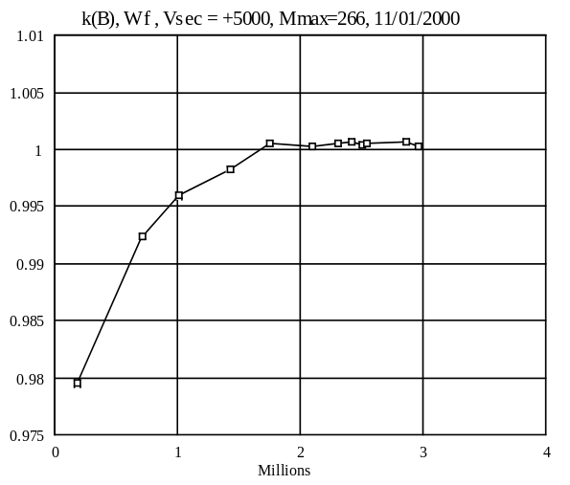 | 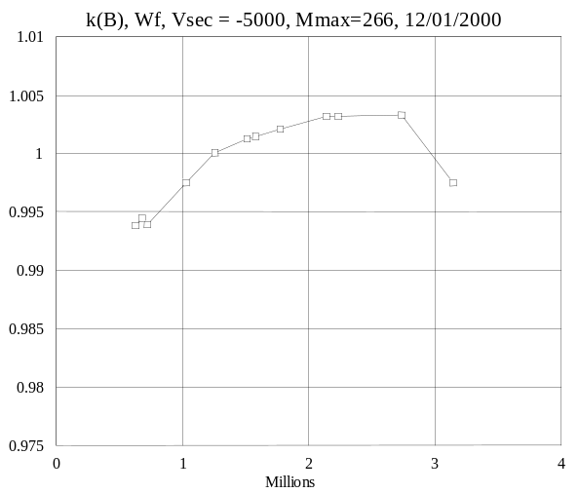

Once the[B, k(B)] table is correctly filled, the basic relationship B² = K * k(B) * M * V allows (MS) to reconstruct a mass calibration table [M, B] at any secondary extraction voltage with an accuracy better than 1/1000. A mass calibration control is strongly recommended for analysis to be run at mass resolution better than 1000.

The [B, k(B)] table depends only on the magnet,
it is a factory setting of the instrument
The [B, k(B)] coefficient does not take into account the cycle (hysteresis and/or thermal effects) dependence on the relationship B(M)

Contents ↑

The [M, B] table
The k(B) table is used to generate a [M, B] table. The [M, B] table is reinitialized whenever either a VALID+SPLE HV or a secondary polarity switching is achieved. At the initialization step, only 16 B field values of the table are computed, corresponding to the masses

1 | 11 | 14 | 23 | 28 | 44 | 56 | 75 | 84 | 112 | 133 | 161 | 197 | 224 | 266 | 399

For any Sple HV, the [M, B] table can be deduced from the [B, k(B)] table, according to the formula
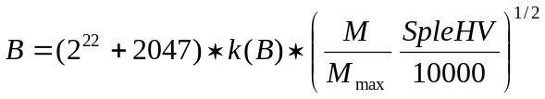

The computation of each of these 16 (M, B) couples involves a cubic spline interpolation (See the appendix) of the [B, k(B)] table. An elementary iterative algorithm is also required since the above formula is not explicit.
Once these 16 values have been computed, any mass M can be addressed, using the same cubic spline interpolation, but directly from the [M, B] table. Note that any new (M, B) can be added to this table by a Mass Calibration action (See the software user's guide/Mass calibration).

The M-B Memory effect and the cycling strategy
At the beginning of this section, it was emphasized that while M is the exact mass which is expected on axis at the exit slit plane, B is not the actual magnetic field within the magnet, which is not uniformly distributed along the main path. B is the input value sent to the servoed system which controls the magnet supply with the constraint that the difference between B and the Hall probe output measurement is zero.
For different physical reasons, magnet hysteresis, Hall sensor thermal effects, eddy currents, the mass M which results from adressing B to the magnet supply depends on the last {... B_{t-3}, B_{t-2}, B_{t-1}} history.
The issue is to determine the value B which will set the required mass M onto the exit axis. The above memory effect produces an uncertainty onto the relationship B(M). This uncertainty is dramatically reduced when the same B series (B_{min}, B₂... B_{i},... B_{max}) is cycled, and providing that the successive B values are growing from B_{min} to B_{max}. After a few number of cycles, the value of the mass produced at the exit axis reaches a steady state, and its uncertainty can be reduced down to a few ppm.
It is therefore mandatory to keep the same B cycles over a mass calibration procedure and the associated analysis. The Mass Calibration software strategy consists therefore to calibrate the values B_{i} associated to the respective masses M_{i} while cycling B according to the analysis cycle defined in the analysis recipe and to avoid getting out of this cycle between the Mass Calibration and the analysis itself.
If a high mass resolution is required, each time the analysis cycle is broken, the mass calibration must be performed again.

From the Mass Calibration stage up to the end of the analysis, the instrument must be kept in the same analysis B field cycle

Contents ↑

Magnet settling time
When an analysis program must switch the magnetic field in order to measure a new mass M after a previous mass M-ΔM, it must take into account the magnet settling time. Practically, this requires to include in the analysis cycle a waiting time between the switching command and the counting time. The waiting time is computed according to the formula:

If ΔM>0

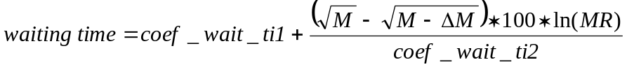
If ΔM<0

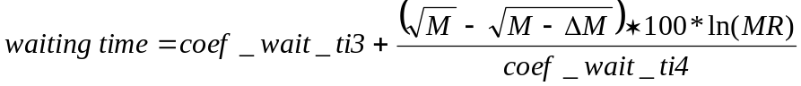

The 5 parameter values, coef_wait_ti1, coef_wait_ti2, coef_wait_ti3, coef_wait_ti4, MR, are stored in the Setup file. Refer to the Tool software user's guide/additional parameters for analysis . MR is the analysis Mass Resolution.

Typical values
 | IMS 7f | IMS 4fE7
coef_wait_ti1 (s) | 0.7 | 0.75
coef_wait_ti2 (s) | 7000 | 10000
coef_wait_ti3 (s) | 0.7 | 0.9
coef_wait_ti4 (s) | 7000 | 10000

For example, with the typical values given above for the IMS 7f, the formulas give respective waiting times of 1 sec and 0.7 sec, for a Mass resolution MR =1000, M=75 and M-ΔM=30.
Note that the IMS 7f magnet settling time is slightly shorter than the IMS 4fE7 because of the laminated structure of the magnet.

Contents ↑

Dynamic transfer and electronic gating

Dynamic transfer
The primary rastering system allows to deflect the primary beam within the sample plane over an area as large as 500 µm. A so large field image cannot pass through the Field Aperture (FA) even at low mass resolution, when the largest FA can be used.

The Dynamic Transfer sketch  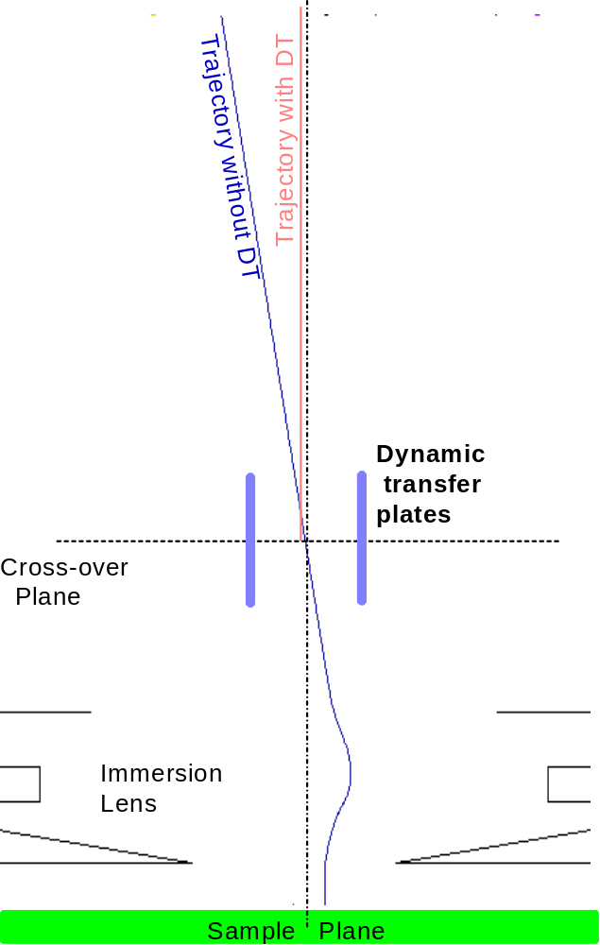 | The so-called Dynamic Transfer (DT) is basically a deflection device, synchronized with the primary raster signal. The DT allows to collect the secondary ions from a very large scanned field in order to provide with a Scanning Ion Microscope (SIM) mode. The SIM mode is opposite to the basically static Microscope mode.  In a first approach, when a fine primary beam is rastered, without any DT system, the so-called Cross-Over (the ion beam section in the Entrance Slit plane, according to the section § The trajectories in the immersion lens region, the cross-over) is not scanned while the beam is scanned within the FA plane.  The DT deflection device is designed for cancelling the scanning of the beam at the FA plane while keeping the Cross-over fixed. As it is shown in the opposite sketch the blue trajectory comes from a point deflected by the primary raster off axis. This trajectory cannot pas through the FA further except it is deflected on-axis (red trajectory) by the so-called Dynamic transfer plates, synchronized with the primary raster.

Contents ↑

Electronic gating, BBS
As it is explained in the section § The Depth Profiling issue, the SIMS way for performing an in-depth analysis consists of scanning the primary probe over the sample plane in order to dig a crater. The secondary ions coming from the crater bottom give the information corresponding to the crater depth d.
In fact, only a restricted area of the crater bottom is at the depth d since the crater edges are not sharp: The crater edge width is approximatively equal to the primary probe size. It is therefore required to limit the analysed area. "Electronic Gating" must be used for limiting the analyzed scanned area when the Dynamic Transfer (DT) mode is activated. It is also recommended to use it even if the DT is not activated in order to achieve an optical gate (see the section § The Depth Profiling issue).
As it was explained in the primary ion otics user's guide, section § Rastering the primary beam, a sequencer determines a 1024x1024 pixels, rastered along a frame of 80 ms. The electronic gating consists of integrating, at each frame, the secondary signal over a W_{G}xH_{G} limited gate, smaller than the 1024x1024 frame.

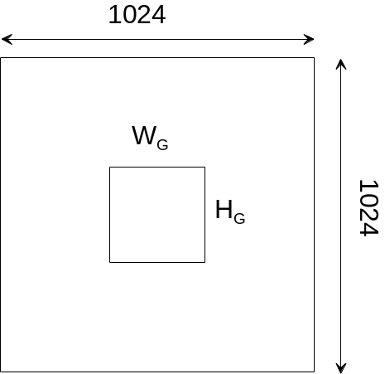

It is pointed out in the section § The Depth profiling issue/electronic gating, that the physical area corresponding to the W_{G}xH_{G} electronic gate is actually larger than W_{G}xH_{G}, since it results of the convolution of the W_{G}xH_{G} gate by the primary probe.
With the IMS7f (#>715), the electron gating is achieved, by blanking the secondary beam before the detection stage. This electronic gating is compatible with the Faraday cup mode. Another advantage is that the EM is used (and therefore aged) only within the gate. This secondary Beam Blanking (BBS) is implemented at the ESA exit, onto the deflection plates DSP1. The blanked beam is deflected along the Y-axis. When the sample HV is set at 10 KV, a ±150 Volt bias onto DC1 plates is sufficient for blanking completely the secondary beam.
The BBS level can be tuned in the Tuning/Synoptics panel, with the path secondary/coupling. A BBS too low level may be confused with a poor detection limit since some crater edge signal may be measured all along the depth profile

The Detection system
The detection system consists of a spherical ESA which allows to switch the secondary beam towards the secondary detectors (See below the section § Secondary Ion Detector). A hole located in the external electrode allows the ions to pass through this Exit ESA when it is set to OFF.  Just after the Exit ESA, a deflector allows to deflect the beam either towards an EM device or towards a Faraday cup device (§Secondary Ion Detector) | 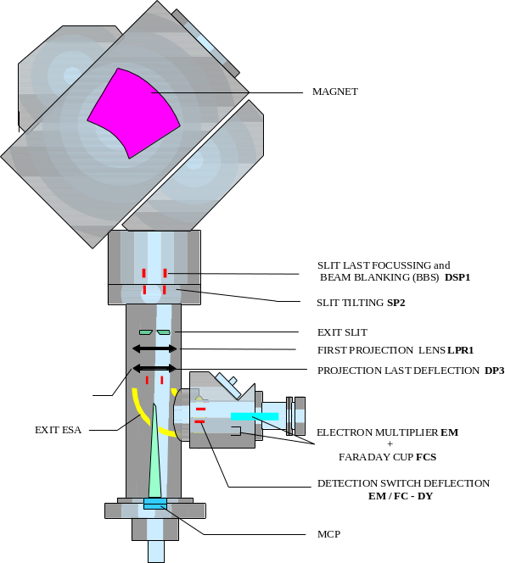

Contents ↑

The MCP Direct imaging (Projection line)
A pair of lenses, LPR1 and LPR2 (called projection lenses) are purposed for projecting onto a MicroChannel Plate (MCP) either an ion sample image or the beam cross section as it is at the exit slit plane. With the help of a phosphorus screen and of a video camera, the MCP allows to displays these ion images (See the section § Microchannel plate/ Fluorescent screen (MCP/FS)).

Image mode corresponds to the first case (sample imaging). This mode is also referred as Ion Microscope Mode.

Slit mode corresponds to the second case (exit slit plane imaging).

Image mode
In the above section §The double focusing spectrometer principles, it is shown in the figure b that a FA image, and a sample image therefore is formed in the magnet. This image can further be transferred onto the MCP plane by the means of the pair of projection lenses.

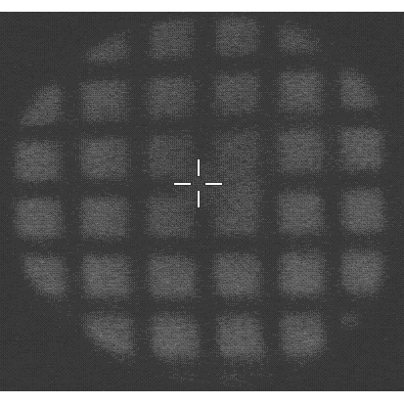
A Si grid sample projected onto the MCP in the image mode

The Image Mode zoom
For a Sample HV of 5000V
 | f(LPR1)  (mm) | f(LPR2)  (mm) | V(LPR1)  (Volts) | V(LPR2)  (Volts) | V(LPR1)  (Digits) | V(LPR2)  (Digits)
FA image =1:2 MCP | 23.7 | 4.93 | 4437 | 4457 | 1817 | 1825
FA image =1:1 MCP | 25.7 | 6.86 | 4340 | 5250 | 1777 | 2150

Slit Mode
The projection set-up can be tuned to project a magnified image of the beam as it is at the exit slit plane. If the exit slit is widely opened, the beam is supposed to be an entrance slit image with more or less aberrations, according to the Field Aperture size. When several species, for instance, a single ion and molecular ions are present at the vicinity of the same mass number, the mass spectrum can be directly observed on the screen provided the mass resolution is suitably adjusted.

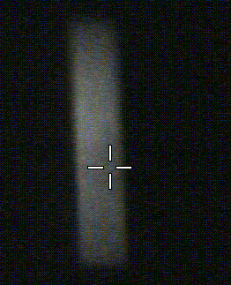
Entrance Slit image projected onto the MCP in the slit mode.

The Slit Mode zoom
For a Sample HV of 5000V
Mass Resol (MR)  for Full MCP Width | F(LPR1)  (mm) | f(LPR2)  (mm) | V(LPR1)  (Volts) | V(LPR2)  (Volts) | V(LPR1)  (Digits) | V(LPR2)  (Digits)
100 | 13.4 | 11.20 | 5175 | 3500 | 2119 | 1433
250 | 16.2 | 5.76 | 4910 | 4280 | 2011 | 1753
500 | 17.4 | 3.22 | 4820 | 4980 | 1974 | 2039

In brief, in the image mode the instrument works as an ion microscope giving directly a mass filtered image of the surface. In the so-called slit mode ⎯ because the image of the slit is observed ⎯ the instrument works as a mass spectroscope (or mass spectrograph).

Contents ↑

Tuning the secondary ion optics

Overview
As it is explained in the section § Controlling the ion optics from the computer , all the ion optics devices are controlled from the computer so that the information corresponding to any given ion optics configuration can be saved in a file called ISF (Instrument Status File). Loading an ISF means that all the values contained in the ISF will be downloaded into the hardware in order to restore the instrument configuration existing when it was saved.
Most of the secondary ion optics variables are contained in the different secondary presets: Maximum area, MCP_image, MCP_slit, FC, EM, Mass Resolution, E-Gun. As it is explained in the section § Controlling the ion optics from the computer, for each type of preset, 10 different configurations are contained in a single ISF, but all these presets, which are also called OIP (See below the section § Main Instrument Parameters (MAP) and Optional Instrument Parameters (OIP)) corresponds to the same Main Analytical Parameters (Source, Impact energy, sample voltage).
For tuning the secondary ion optics, it is necessary to have obtained at the sample plane, a primary spot large enough to contain the intersection between the sample plane and the secondary axis. This primary spot does not need to be well focused. It will ve generally largely rastered in order to cover completely the area observed in the secondary alignment procedure.
Tuning the secondary ion optics involves the instrument direct imaging capability (see above the section § The MCP Direct imaging). It is therefore necessary to have the MCP device, including its video camera correctly working.

Tuning the secondary ion optics involves mainly the MCP direct imaging. The primary beam must be present at the sample plane, onto the secondary axis, but it is not required to be well-focused.

The operator does not need to make a new ISF corresponding to a new set of MAPs. He must just download an already existing ISF and check that all the settings are correct (See the section § Routine secondary ion optics check of an existing ISF).
The expert user must be able to transform an ISF corresponding to given MAPs to another given MAPs.

Contents ↑

Routine secondary ion optics check of an existing ISF (operator level)
This routine secondary ion optics check is a part of the overall routine check of an existing ISF (See in the primary ion optics user's guide the section § Tuning the primary column). So, it is assumed there that the first steps of this routine are still completed.
- Source started
- Preliminary steps (vacuum, valves, sample stage)
- Checking the source

Before checking some secondary ion optics settings, the operator must select a suitable mass for displaying an ion image with the MCP device.

Select a suitable mass according to the secondary ion polarity, the ion source and the calibration sample
It is desirable to select a mass which will provide with a well contrasted sample image in the microscope mode.

Cs source
 | Ta/Si Mireas | GaAs/Si Mireas | Cu/Al grid
Secondary positive | Si⁺, CsSi⁺ | Ga⁺, CsGa⁺ | Al⁺, CsAl⁺
Secondary negative | Si⁻ | As₂⁻ | AlO⁻, Al₂⁻

Duo source
 | Ta/Si Mireas | GaAs/Si Mireas | Cu/Al grid
Secondary positive | Si⁺, CsSi⁺ | Ga⁺ | Al⁺
Secondary negative | Si⁻ | As₂⁻ | Al⁻, Al₂⁻

Now, the operator may want to achieve the following secondary ion optics checks:
- Checking the MCP image presets (LPR1)
- Checking the MCP Slit preset (LPR1)
- Checking the Slit Preset energy focusing (LCOUP)
- Checking the Maximum area preset (IMM, LTR1, DT-CA)
- Checking the Slit preset Exit beam (HC3, Slit stig)
- Checking the FC & EM preset
- Checking the DT preset

For general information about the so-called presets, see below the section § Controlling the ion optics from the computer and the Tuning software user's guide.
For building a new secondary preset, see below the section § Building a new secondary preset.
Checking the MCP image projection presets (LPR1)
The MCP Image preset contains the 2 projection lenses LPR1 and LPR2. LPR2 will determine the sample image magnification (see below the section § Building new secondary presets).
Conditions: Largest FA (1800µm). Transfer preset:150 µm Maximum Area in 1800µm FA. Large Exit Slit (600µm)
- Open the MCP Image calibration box
- LPR1 is correctly tuned if the FA&Sample image is fixed when moving the magnetic field. For a large enough magnetic field variation, the sample image must go out, but without any motion.
- Valid the MCP_Image preset.
It must be emphasized that when this criterion is met, the FA image cannot be perfectly focused. This tuning is very important: If LPR1 is not well-tuned, the primary spot position, as it is displayed on the real time screen, depends accurately on the magnetic field setting. This can lead to some beam positionning error.

Checking the MCP Slit projection preset (LPR1)
The MCP Slit preset contains the 2 projection lenses LPR1 and LPR2. LPR2 will determine the slit image magnification (see below the section § Building new secondary presets).
Conditions: Largest FA (1800µm). Transfer preset:150 µm. Largest CA (400µm), largest Entrance Slit (400µm). Medium Exit Slit (300 µm)
- Open the MCP Slit calibration box
- Tune LPR1 for focusing the Exit Slit image both edges.
- Valid the MCP_Slit preset.
It must be emphasized that LPR1 must not be tuned for optimizing the Entrance Slit image. If the Entrance Slit image is well-focused, but not the Exit Slit, The user could believe that a high mass resolution could be obtained that would not be the case when running further an analysis.

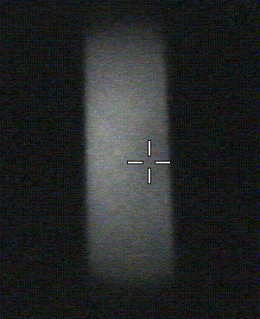 | Exit Slit image displayed with an Image projection zoom correctly tuned  (At Sple HV=5000 Volts:LPR1=1928, LPR2=1570) | 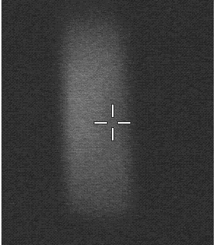 | Exit Slit image displayed with an Image projection zoom not correctly tuned  (At Sple HV=5000 Volts:LPR1=1918, LPR2=1570)

Checking the energy focusing in the MCP Slit mode. (LCOUP)
Select an ion mass with a narrow energy distribution (Cs, if possible). Energy Slit widely opened. Exit Slit widely opened. CA 400µm. Entrance slit 100 µm or less. Select Slit mode. An Entrance Slit is displayed.
- Open the MCP Slit calibration box
- Assign Sple HV to the thumwheel with the Synoptics/Sample and Raster.
- When Varying the Sample HV, the Entrance Slit must not move along the X axis.
- If not, vary the LCOUP .
- Valid the MCP_Slit preset.
LCOUP typical value: 3275 Volts or 1342 digits for Sple HV= 5 KV
The validated LCOUP value will be also included in the EM and FC preset.

Checking the Maximum area preset (IMM, DT- CA X&Y)
Conditions: On the test sample, select a grid the step of which is 25 µm. Primary Raster=200µm, DTOS=OFF. Entrance slit max. FA 1800µm. CA 400 µm. Exit Slit Widely opened. Select Image mode.
- The preset MCP_Image must have been checked previously.
- Open the Maximum Area calibration box
- Tune both the immersion lens IMM and the DT-CA X&Y deflectors for the finest grid image.
- Tune both the immersion lens IMM and the transfer stigmator s1 and s2.
- Check LTR1 and LTR2 are close to the Transfer zoom tables (see above the section § The matching transfer zoom). If no, call an expert user.
- Measure the actual sample area size within the FA by counting the number of grid steps.
- Edit the measured value in the editing field Maximum Area Label.
- Valid the Maximum Area preset.

These 3 images correspond to the medium "150µm"transfer mode (LTR1= LTR2=) within a FA of 1800 µm. Sample Si grid step is 25µm.
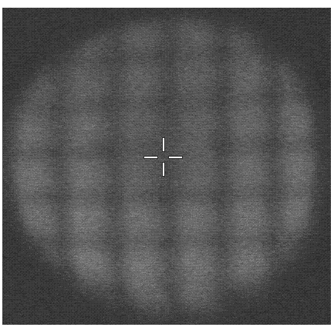 | 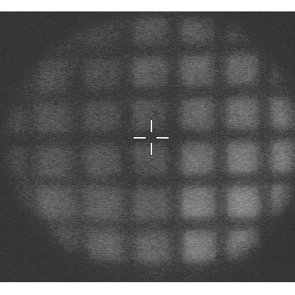
CA = 400µm  Immersion lens and transter stig not optimized:  Transfer Stig = (0, 3)  Imm=22573 | CA = 400µm  Immersion lens and transfer stig optimized:  Transfer Stig = (-21, -5)  Imm=22553 | CA = 200µm

Checking the Slit preset Exit beam (HC3, Slit stig)
Exit Slit Widely opened. CA 400µm. Entrance slit 100 µm or less. Select the MCP Slit mode. An Entrance Slit is displayed.
- Open the MCP Slit calibration box.
- Tune both HC3 (in the hexapole option case) and Slit Stig for the finest Entrance Slit image edges.
- Ima Stig 45 may also be adjusted to align the entrance slit image with respect to the exit slit.
- Valid the MCP_Slit preset.
The validated HC3 and Slit Stig values will be also included in the EM and FC preset.

The 4 entrance slit images are displayed in the Slit mode, the Slit projection zoom being perfectly tuned with respect to the Exit Slit focusing..
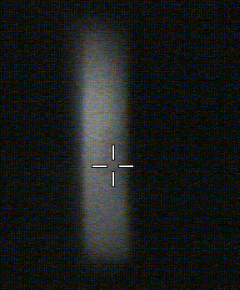 | 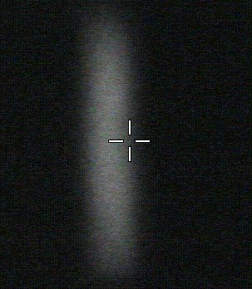 | 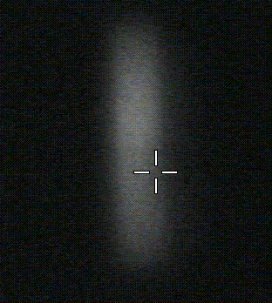
FA=1800µm  Slit Stig and HC3 are optimized  Slit Stig=14  HC3=187 | FA=1800µm  Slit Stig is not optimized  Slit Stig =-56 (instead of 14)  HC3=187 | FA=1800µm  HC3 is not optimized  Slit Stig=14  HC3=0 (instead of 187) | FA=750µm  The mass resolution is always impoved when reducing the FA diameter.  Slit Stig =14  HC3=187

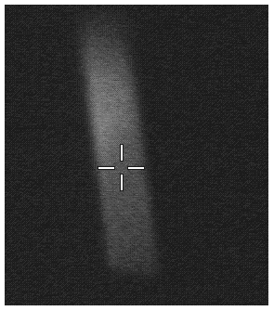 | FA=1800µm  The tiliting effect of Ima Stig s2:  Ima Stig s2=-200  Quad=14  HC3=187

Checking the EM & FC preset
Any condition, providing that the secondary signal is less than 2Mcps
- Select FCs for checking that the secondary signal is less than 2 Mcps.
- If the signal is more than 2 Mcps, decrease it (change the selected Mass, or change the primay beam or reduce the Entrance Slit width.)
- Select EM
- Open the EM calibration box
- Tune Exit ESA for maximizing the signal.
- In the Synoptics, tune EM-DY for maximizing the secondary signal.
- Valid EM.
- Switch to FC.
- In the Synoptics, tune FC-DY for maximizing the secondary signal

Checking the DT preset
Conditions: Largest FA (1800µm). Transfer preset:150 µm Maximum Area in 1800µm FA. Large Exit Slit (600µm). Focused primary spot. Primary Raster 150µm or 200 µm. Select the MCP Image mode.
- Open the DT calibration box.
- Tune DT RASTER X&Y for miminizing the displayed spot.
- Valid DT.

Contents ↑

Building new secondary presets
For general information about the so-called presets, see below the section §Controlling the ion optics from the computer and the Tuning software user's guide. It must be emphasized that some presets are bound up with each other: MCP Slit, MCP Image, Slit, Image, FC, and EM. For instance, pressing VALID in the MCP_SLIT box validates both the Slit and the MCP Slit preset. The same LCOUP and HC3 values which are validated for the Slit preset are also taken into account for the EM and FC preset. This is precisely described in the Tuning software user's guide.
For just checking a preset, see above the section § Routine secondary ion optics check of an existing ISF.

Building a new MCP image projection preset (LPR1, LPR2)
Each of the 10 possible presets corresponds to a given image magnification.
Conditions: Largest FA (1800µm). Transfer preset:150 µm Maximum Area in 1800µm FA. Large Exit Slit (1200µm)
- Open the MCP Image calibration box
- For a given magnification, set LPR2, according to the above section § The MCP Direct imaging (Projection line)
- LPR1 is correctly tuned if the FA&Sample image is fixed when moving the magnetic field. For a large enough magnetic field variation, the sample image must go out, but without any motion.
- Valid the MCP_Image preset.
It must be emphasized that when this criterion is met, the FA image cannot be perfectly focused. This tuning is very important: If LPR1 is not well-tuned, the primary spot position, as it is displayed on the real time screen, depends accurately on the magnetic field setting. This can lead to some beam positionning error.

Building a new MCP Slit preset (LPR1, LPR2)
Each of the 10 possible presets corresponds to a given slit magnification.
Conditions: Largest FA (1800µm). Transfer preset:150 µm. Largest CA (400µm), largest Entrance Slit (400µm). Medium Exit Slit (300 µm)
- Open the MCP Slit calibration box.
- For a given magnification, set LPR2, according to the above section § The MCP Direct imaging (Projection line)
- Tune LPR1 for focusing the Exit Slit image both edges.
- Valid the MCP_Slit preset.
It must be emphasized that LPR2 must not be tuned for optimizing the Entrance Slit image. If the Entrance Slit image is well-focused, but not the Exit Slit, The user could believe that a high mass resolution could be obtained that would not be the case when running further an analysis.

Building a new Maximum area preset (IMM, LTR1, LTR2, STIG, DT-FA, DT-CA)
Each of the 10 possible presets corresponds to a given sample image magnification within the Field Aperture (FA)
Conditions : On the test sample, select a grid the step of which is 25 µm. Primary Raster=200µm, DTOS=OFF. Entrance slit max. FA 1800µm. Exit Slit Widely opened. Select Image mode.
- The preset MCP_Image must have been checked previously.
- Open the Maximum Area calibration box
- Set LTR1 and LTR2 for the required maximum area (see the Transfer zoom tables in the above section § The matching transfer zoom).
- Tune both IMM and DT-CA X&Y for the finest grid image. STIG s1 and STIG s2 may also be tuned for improving the image quality, but they are expected to be close to zero.
- Measure the actual sample area size within the FA by counting the number of grid steps. If the measured value is not exactly as desired, play with LTR1 and LTR2.
- Edit the measured value in the editing field Maximum Area Label
- Tune DT-FA X&Y for centering the analysis location within the FA
- Valid the Maximum Area preset.

Building the Slit preset (LCOUP, HC3, Slit stig, Ima Stig)
Only 2 possible configurations for the set of parameters included in this preset: The Slit configuration and the Image configuration. The Slit configuration corresponds to best tuning of the double focusing spectrometer for a high mass resolution analysis. See the next paragraph for the Image configuration.
Conditions: Exit Slit Widely opened. CA 400µm. Entrance slit 100 µm or less. Select the MCP Slit mode. An Entrance Slit is displayed.
- Open the MCP Slit calibration box.
- Tune the spectro lens LCOUP. See the procedure above, in the section § Routine secondary ion optics check of an existing ISF (energy focusing).
- Tune both HC3 (in the hexapole option case) and Slit Stig for the finest Entrance Slit image edges.
- Tune Ima Stig 45 for aligning the entrance slit edges with respect to the axit slit edges.
- Valid the MCP Slit preset.
The validated HC3 and Slit Stig values will be also included in the EM and FC preset.

Building a new Image preset (LCOUP, HC3, Slit stig, Ima Stig)
Only 2 possible configurations for the set of parameters included in this preset: The Slit configuration and the Image configuration. The Image configuration corresponds to the best tuning of the double focusing spectrometer for viewing an ion sample image in the microscope mode . See the previous paragraph for the Slit configuration.
Conditions: Largest FA (1800µm). Transfer preset:150 µm Maximum Area in 1800µm FA. Large Exit Slit (1200µm)
- Start with the same paramester configuration as for the Slit preset. The Image configuration must be very close to the Slit configuration.
- Open the MCP Slit calibration box.
- It is allowed to vary all the preset parameters (LCOUP, HC3, Slit stig, Ima Stig) to improve the ion image, in particular Ima Stig both components.
- It is forbidden to change LPR1 and LPR2.
- Valid the Ima Slit preset.

Building the EM & FC preset (LPR1, LPR2, Exit ESA, EM-DY, FC-DY)

EM and FC are the two detection preset. They are bound up with Slit and Image and bound up with each other. See the precise description in the Tuning software user's guide.
Conditions: Any, providing that the secondary signal is less than 2Mcps
- Select FCs and for checking that the secondary signal is less than 2 Mcps.
- If the signal is more than 2 Mcps, decrease it (change the selected Mass, or change the primay beam or reduce the Entrance Slit width.)
- Select EM
- Open the EM calibration box
- Tune Exit ESA for maximizing the signal.
- In the Synoptics, tune EM-DY for maximizing the secondary signal.
- LPR1 and LPR2 must be set for producing the best flat top peak (See the Basic ion optics user's guide/ Mass resolution)
- Valid EM.
- Switch to FC.
- In the Synoptics, tune FC-DY for maximizing the secondary signal

Building the DT preset
Conditions: Largest FA (1800µm). Transfer preset:150 µm Maximum Area in 1800µm FA. Large Exit Slit (600µm). Focused primary spot. Primary Raster 150µm or 200 µm. Select the MCP Image mode.
- Open the DT calibration box.
- Tune DT RASTER X&Y for minimizing the displayed spot.
- Valid DT.

Contents ↑

Miscellaneous Tuning
Main ESA
Conditions: If possible, select a mass with a narrow energy dispersion (e.g. Cs). Exit Slit and Energy Slit widely opened. CA 400µm. Entrance slit 100 µm or less. Select the MCP Slit mode. An Entrance Slit is displayed.
Typical value, for Sple HV=5000Volts, 25360 digits, that corresponds to 628 Volts applied onto the external electrode and 559 Volts applied onto the external one.
- Open the ion optics synoptics, and assign both LCOUP to the ball track and the main ESA to the thumbwheel by selecting Secondary/Spectrometer/ 1st line.
- Vary LCOUP. If ESA is tuned correctly, the slit image must not move horizontally.
- If the slit image moves horizontally, change the value of ESA in order to reduce this motion. The magnetic field must then be changed as well for keeping the slit image at the MCP center. Once the correct ESA value is obtained, if the magnetic field was varied, update the mass calibration table with a Shift Calib (See the the Tuning software user's guide)

DP3 X&Y, DSP1 X&Y
The DP3 X&Y deflector is targetted to center the beam with respect to the MCP
Condition: FA=1800n µm.
- Select Image
- DP3 X& Y must be tuned for aligning the FA image with respect to the MCP
- Switch to Slit
- DP1 X& Y must be tuned so the slit image is centered as well with respect to the MCP. Tune successively DSP1 and DP3.

DC2 X&Y (Hexapole option case)
DC2 X&Y are normally set to zero, but DC2 Y may be used for centering the FA image within the magnet ends and DC2 X can be used for a very accurate focusing of the Entrance Slit image.

Normal Electron Gun (NEG)
See the NEG user's guide.

Contents ↑

The Mass Resolution and Aperture presets
In this section, the preset storing procedures are valid only for the motorized aperture option, but the centering procedures are valid for both the manual and the motorized apertures.

The Contrast Aperture (CA)
The CA device consists of a set of 4 apertures mounted on a bar driven in X and Y. The different aperture centers are spaced by 2.333 mm.
There are 4 different CA presets, corresponding to 4 different stops locations on the same bar. The CA presets must be tuned in two steps:
- Tuning the different presets with respect to each other
- Centering the current CA
1. Tuning the different presets with respect to each other
- Select Slit
- Open widely both the entrance and the exit slits.
- Select the CA preset corresponding to the smallest CA.
- Open the CA calibration box.
- Move the smallest CA image to the screen center.
- VALID.
- Select the second CA preset. Move its image to the screen center, VALID
- Same operation for tha lest 2 CA presets.

2. Centering the current CA
It is possible to shift all the CA presets together by shifting one preset (Open this CA preset calibration box, and then, click "Drift correction").
- Select Image mode, with the largest FA.
- Select the Maximum Area preset corresponding to 60 µm.
- Open the CA calibration box.
- The criterion for a good CA centering is that when varying LTR2, the sample image center must not be shifted. If it is not the case, adjust the CA X&Y position.
- Click Drift Correction.
- Along this procedure, check that the Entrance Slit is not stopping the beam (Slit mode). If it is the case, move the Entrance Slit.

The Entrance Slit (Ent S)
The ENT S device consists of 2 bars mounted on a deformable ring. Pressing the deformable ring enlarges the width between the bar edges. The deformable ring is driven in X and W (Width)
There are 10 different ENT S presets corresponding to different widths. The ENT S X centering is not contained within the ENT S preset.
It is recommended to arrange the ENT S presets in combination with the Exit Slit presets so that both the Ent S and the Exit Slit of the same number can be selected together for the same application. It must be kept in mind that the Ent S image will be magnified by 1.5:1 at the Exit Slit plane.
- For defining an Ent S preset, open the Ent S calibration box, set the required width and click VALID.
- For centering the Ent S, open the synotics box (Secondary/Transfer), select the Slit mode and the largest CA.Center the Ent S image with respect to the CA image.

The Field Aperture (FA)
The FA device consists of a set of 4 apertures mounted on a bar driven in X and Y. The different aperture centers are spaced by 2.333 mm.
There are 4 different FA presets, corresponding to 4 different stops locations on the same bar.
- For validating the different presets with respect to each other, same procedure as for the CA.
- As for the CA presets, It is possible to shift all the FA presets together by shifting one preset (Open this FA preset calibration box, and then, click "Drift correction").
- Select Image Mode, with the largest FA.
- When moving the FA along the Y axis, its image can reach the horizontal magnet ends which are displayed with the FA & Sample image. The FA must be centered between both magnet ends.
- When moving the FA along the X axis, its image can reach the Vertical E-gun coil pole ends which are displayed with the FA & Sample image. The FA must be centered between these both coil poles.

The Energy Slit (Ener S)
The Ener S device consists of two bars driven undependently along the X axis. The Energy window width W is defined by the distance between both inner bar edges. Both moving bars are controlled though bound up parameters: Position and width. When the Ener S is varied, both bar position are moved simultaneously of the same step while when the Ener S width W is varied, only the Ener S bar corresponding to the high energy bar (outer bar) is moved. The Ener S preset contains both the Ener S position and width.
The Energy Slit is normally used for limiting the ion high energy, as it is shown in the sketch below.
- Select a species with a narrow energy distribution width (Cs)
- Select a detection mode (EM or FC)
- Open the Energy Slit calibration box
- Tune W for a narrow energy window width
- Tune X for centering the energy window onto the beam (max ion signal)
- Tune W for the required energy window width (e.g. 40 eV)
- Decrease X of a few eV for setting a margin between the low energy slit edge and the low energy curve edge. (See the sketch)
- VALID.

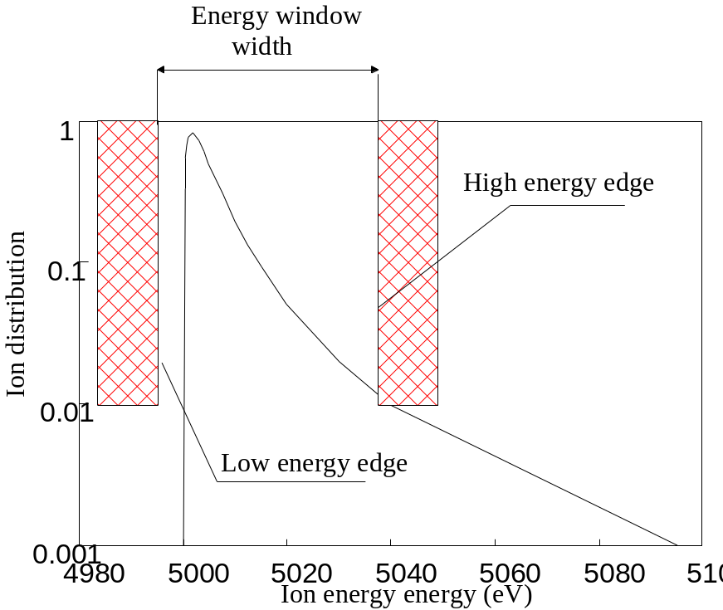

The Exit Slit
As for the ENT S , the Exit Slit device consists of 2 bars mounted on a deformable ring. Pressing the deformable ring enlarges the width between the bar edges. The Exit Slit deformable ring is driven only in W (Width).
The Exit Slit width is tuned according to the required Mass Resolution. See above the section § The spectrometer aberrations and the mass resolution issue, and the Basic ion optics user's guide .

Contents ↑

Modifying the Secondary voltage (Sple HV)
Modifying the secondary voltage may be required, for example, for reducing the effect of the secondary extraction field upon the low energy primary trajectories, as it is discussed above in the primary ion optics user's guide, section § Primary beam impact angle and the landing issue. The secondary trajectories will not be affected by the variation of the secondary acceleration voltage providing that all the electrostatic parameters are varied linearly and the the Magnetic field is varied as V^{1/2}. This is automatically achieved by the procedure VALID Sample HV:
- Open the Synoptic box in the Tuning operator interface (See the Tuning software user's guide).
- Click Sample HV
- In the VALID box which was opened, check that the previous Sample HV is actually displayed in the Previous field. In this case, click Cancel.
- Assign the operator keyboard Z thumbwheel to Sample HV by clicking Secondary in the Synoptic box. Adjust Sple HV to the new value.
- Click Sample HV. Then the previous value is displayed in Previous and the new one is displayed in Valid. Click OK.
- All the secondary parameters are automatically updated, including the Mass Calibration table, but it is necessary to recall the mass used for the tuning.
- The primary Last Lens (LPRIM4) and Beam Pos must then be re-adjusted.
- In the left hand side Tuning menu bar, click Beam Pos for assigning the keyboard thumbwheel to Beam Pos X, Last Lens and Beam Pos Y. Further, when re-clicking Beam Pos, The respectives differences Δx, Δlens, Δy will be transferred upon all the Primary Beam presets.
- Adjust Beam Pos Y&Y with the primary spot display conditions (Beam ON, Raster + DTOS ON, Image) for centering the primary beam spot at the center of the field of view.
- Readjust the primary Last Lens for the best primary spot focusing.
- Click Beam Pos for updating all the ISF primary presets.

Contents ↑

Secondary Ion Detectors

Direct ion image detector (Microscope mode)
The projection system (projector lenses) is designed to focus onto an image detector the mass filtered image of the sample surface. The IMS 7f and 4fE7 can be equipped with two ion image detectors : microchannel plate/fluorescent screen assembly and accessorely resistive anode encoder.

Microchannel plate/ Fluorescent screen (MCP/FS).
This system consists of a microchannel plate device coupled to a fluorescent screen. The microchannel plate converts secondary ions in electrons, the fluorescent screen converts electrons in photons. The fluorescent screen image is acquired by the means of a CCD camera and displayed on the real time screen.

A MCP is an assembly of small channels ( ∅ ≈ 10 µm). Each channel is a small hollow glass tube with the inner surface covered by a SiO2 emissive layer ( or a conductive layer ) compounds. When a secondary ions strikes the semiconductor surface, there is secondary electron emission, these electrons are accelerated and multiplied by collision cascades in the channel. The useful surface of the MCP device (open area/total area ratio is more than 50 %).

The MCP/FS system is schematically represented on the hereunder figure

The MCP gain (number of secondary electrons produced per secondary ion) is adjustable (typically from a few 10² to 10⁴) by controlling of the potential applied across the detector. This potential can vary from 400 V to 1500 V. The higher the potential the higher the gain. The fluorescent screen is brought at potential which is automatically adjusted in order to keep a constant extraction voltage of 5000 V for the electrons which focuses the e⁻ in a spot of about 70 µm in diameter onto the screen. The adjustable gain of the MCP/FS image detector offers the capability of imaging over a very wide dynamic range.

At a given potential, the MCP gain depends on the mass of the imaged species. The MCP gain decreases with the increasing atomic number of the species. This effect must be taken into account for quantitative analysis of images (See for instance Mantus and Morrison publication in Analytical Chemistry Vol 62, n° 11, June 1, 1990).

The lateral resolution of the MCP/FS detector is limited by the diameter of the micro channels and the blooming effect undergone by every elementary electron beam in the acceleration space between the exit face of the microchannel plate and the fluorescent screen. For a microchannel plate of a diameter of 26 mm (that is the case for the IMS 7f and 4fE7), an electron beam blooming effect of 70µm and an image formed onto the detector with a magnification of ×520 (corresponding to a field of view of 50 µm of the sample surface), the intrinsic lateral resolution of the MCP/FS assembly is equal to :

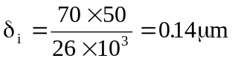

In this case, the intrinsic resolution of the MCP δ_{i} does not significantly limit the intrinsic lateral resolution δ_{m} of the mass spectrometer in the microscope mode (δ_{m} ≈ 0.5 µm). But if the field of view was 150 µm, the δ_{i} contribution(0.5µm also) would become significant compared to δ_{m}. The higher the image magnification on the detector (adjustable by the setting of the projector lenses) the higher the lateral resolution for direct ion images.

Contents ↑

Resistive anode encoder (RAE).
This system consists of a microchannel plate device coupled to a resistive anode encoder system. The microchannel plate converts secondary ions in electrons. The RAE generates a pulse for each event (secondary ion incoming on the channel plate) and determines the spatial position of the gravity center of the charges deposited by the electron flux related to each event by sharing the charge between its four corners. From the RAE outputs it is therefore possible to form an ion mapping on a CRT.

The RAE system is schematically represented on the here under figure

The advantage of the RAE system is to form ion images in a pulsing mode which eliminates the mass dependence effect of the MCP system. The drawback is a limited dynamic range due to a rather large dead time of the RAE detector (3µs) which does not allow to take fully advantage of the high count rates achievable in the microscope mode.

Contents ↑

Ion detectors for counting mode.
The IMS 7f and 4fE7 are equipped with two types of ion detectors for the counting mode : one Faraday cup (FCs) and one electron multiplier (EM). The combination of the both Faraday cup and electron multiplier provides a very high dynamic range for the secondary intensity measurements.

The Faraday cup (FCs) and electron multiplier (EM) are used to measure count rates in the range [5×10⁵ ; 5 × 10⁹] and [10⁻¹ ; 10⁶] c/s, respectively. The overlap of the intensity ranges allows to combine both detectors within a given analysis. The two detectors are mounted side by side on the secondary beam trajectory after the second electrostatic analyzer of the instrument (projection part). The deflector located in front of the detector assembly is used to apply a fast switch of the secondary beam from one detector to the other.

Contents ↑

Faraday cup (FCs)

The FCs channel description
The Faraday cup is an hollow cylinder with large ratio length/diameter isolated from the instrument ground. In order to measure accurate secondary ion intensities it is mandatory to prevent the secondary electrons induced by the ion bombardment of the Faraday cup walls from escaping of the Faraday cup. This is achieved by placing a repeller (a plate negatively biased) in front of the Faraday cup.

A schematic drawing of the IMS Faraday cup system is shown in the here under figure :

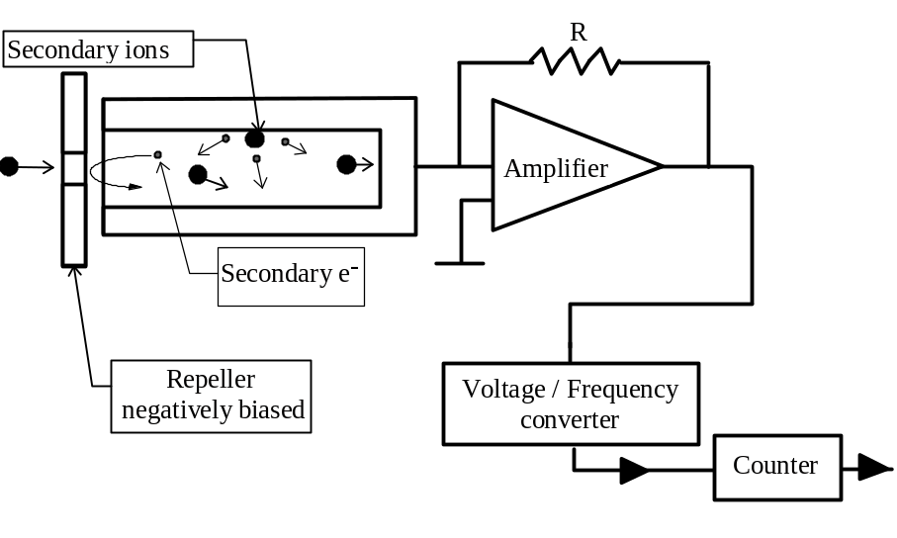

The charges brought by the secondary beam focused into the Faraday cup produces a current which is converted into a voltage by a high impedance amplifier. This voltage is sent at the input of a voltage/frequency converter.

The FCs channel resolution and thermal drift
The maximum input voltage of the V/F converter is 10 V and the resistor R is of 10¹⁰ Ω. The maximum count rate which can be measured with the Faraday cup system is therefore

Imax = 10 /(10¹⁰ x 1.6 10⁻¹⁹ ) = 6 x10⁹c/s

The typical thermal drift is 4000 c/s/°C.

In order to work in the linear range of the V/F converter an offset is applied on the preamplifier (typically equivalent to few Millions of c/s). The intensities measured by means of the Faraday cup must be corrected of the offset (See the Software user's guide, Tools/FCs)
The polarity of the preamplifier is automatically adjusted by the automation system according to the polarity of the secondary ion beam.

The FCs Channel settling time, definition of N_{faraday} .
The FCs channel response time is of the same order of magnitude as the frame time. Any FCs measurement involved within an analysis must therefore take into account both the FCs channel T_{fcs} time constant and the required precision prec. It is therefore useful to define N_{faraday} as the number of frames corresponding to the FCs settling time at a prec precision. prec is expressed in %.

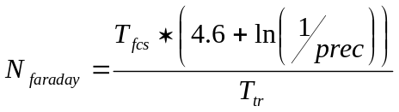
That leads to N_{faraday}=4.6 (rounded to 5) if prec=1% and T_{fsc}=T_{fcp}.

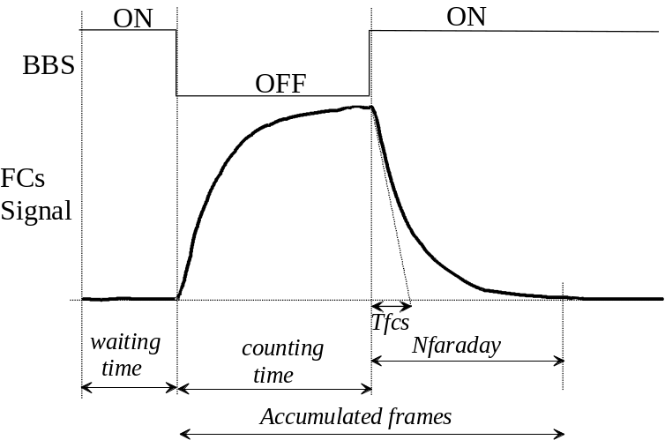

All these parameters are stored in the setup file (refer tothe user's guide Tools/FCs)
Contents ↑

Electron multiplier (EM)

Principles
Overview
TheIMS 7f and 4fE7 are equipped with an electron multiplier (EM) working in a direct pulse counting mode. The most commonly used EM is manufactured by ETP. It is made of 21 active film dynodes.
A secondary ion striking the first dynode (conversion dynode) of the EM induces a secondary electron emission. Then, these electrons are accelerated through the successive dynode stages in order to amplify the secondary electron current. A gain (mean number of electron per secondary ions) of about 10⁸ is obtained. For most of the secondary ions reaching the detector, a charge pulse is produced at the last dynode output. The charge amplitude is converted in voltage, and the pulse amplitude, in Volt is proportionnal to the EM gain. Note that some incident ions do not produce any signal at the EM output (See below the sections § EM output and discriminator threshold ).

It may occur that two or more ions impinge the EM first dynode within a time interval small enough to be detected as a single ion. This effect is known as EM dead time and is developed in the section §Dead time and Yield corrections. Dependance on the gating.

The amplitude of every pulse is randomly distributed according to a distribution law currently displayed by the PHA Distribution Curve (PHA states for Pulse Height Amplitude). The knowledge of this distribution is therefore very helpful to optimize the setting of the EM High Voltage (HV), and Threshold (See the section §EM output and discriminator threshold). Checking this curve shape also used for controlling the EM aging (See the section § EM aging).

Practical tuning
See the Software user's guide, Tools/EM

Contents ↑

EM output and discriminator threshold
Definitions
Due to the statistical variation of the secondary electron emission, every secondary ion reaching the first dynode of the electron multiplier does not produce the same number of electrons. Note that the percentage of those producing at least one electron is called DQE (Detection Quantum Efficiency).
More generally, the ion/electron conversion efficiency corresponds to the response of the first dynode. It includes the DQE, and the distribution law P(k) which gives the probability for one ion to produce k electrons. The ion/electron conversion efficiency depends on the incident ion features: mass, velocity and nature (single or molecular) species.
The EM gain is the ratio between the electron output current and the ion input current. It involves both the first dynode ion/electron conversion efficiency and the other dynodes amplification effect. This last amplification depends on the EM HV and also on the EM age.
The PHA distribution is the probability P(V) for an EM output pulse to have a voltage amplitude V. As the EM gain, it results also on both the first dynode ion/electron conversion efficiency and the other dynode amplification effect.
The EM Yield is the ratio between the number of output pulses counted after the EM discriminator (see below) and the number of incident ions.

The EM detection channel
The first electrons produced by the first dynode when impinged by an ion are amplified by the successive stages the electron multiplier with a gain in the range of 10⁸ (EM gain). As it is displayed on a PHA distribution curve, the pulses detected at the EM output do not have the same amplitude (see the figure below). A preamplifier converts the charge pulses into voltage pulses and amplifies them. Then, a discriminator selects the pulses larger than a given threshold.
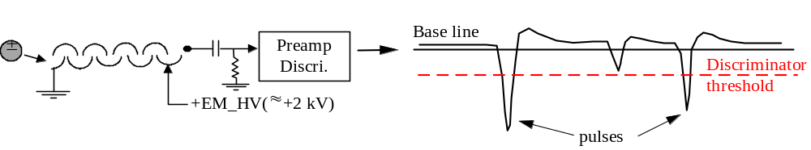

Typical PHA distribution curve 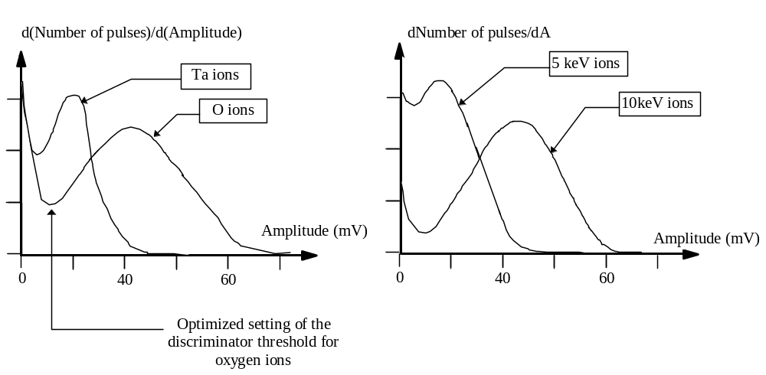

The large number of pulses with a small amplitude (first part of the pulse amplitude distribution) are due to the system noise. These pulses are therefore eliminated by using a discriminator with an adjustable threshold. The setting of the threshold is the result of an optimization which minimizes the EM background ( typically < 5 counts/mn) and to EM detection efficiency (number of counted pulses per secondary ion). This optimized threshold corresponds to the first minimum of the PHA distribution curve. For displaying a PHA curve, See the Software user's guide, Tools/EM_PHA

Note that, for instance, when the secondary ion extraction voltage is varied the discriminator threshold should be re-adjusted in order to work under optimized conditions.

Contents ↑

Dead time and Yield corrections. Dependance on the gating
Dead time τ
At a given accuracy, the highest secondary ion intensity which can be measured is limited by the time resolution of the pulse counting system. The so-called dead time of the pulse counting system is the time spent after each event before being able to detect the next one.
Let N_{c} the number of counted pulses per second at the pulse counting system, and τ the dead time of this system. Assuming that the system was unabled during N_{c}*τ, it is possible to deduce the EM output count rate N'

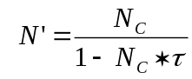

This is the basic dead time correction formula. For a dead time of 25 ns and a true pulse rate of 10⁶ pulse/s, a dead time correction of 2.4 % must be applied to the counted rate. As it can be easily corrected by a mathematical formula, the EM dead time is not an instrument limitation, providing τ is precisely known. That is why a delay line circuit is implemented on the discriminator board. Switches on this PCB allow to set the dead time to ...

EM detection Yield Y_{EM}

The EM detection Yield Y_{EM} is defined as
Y_{EM} = (EM output pulse rate/EM input ion rate)

It can be measured on the instrument by comparing the measured EM count rate and the FCs count rate in the range of 10⁶ c/s.

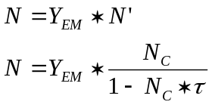

The deadtime correction depends also on the gating
It is worth to emphasize that whenever either optical or electronical gating is set (see above §The Depth Profiling Issue/Overview), the instantaneous count rate, within the gate, can be much larger than the measured count rate averaged over a frame. The dead time correction must therefore take into account the ratio η_{GATE}

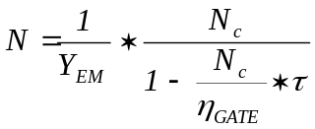
The ratio η_{GATE} is the area ratio gate/frame, so that N_{C}/η_{GATE} is actually the instantaneous count rate since N_{C} is the count rate averaged over the whole frame while all the counts occur only over the gate.
For determining η_{GATE}, both electronical and optical gate must be considered.
- In the electronical gate case, the calculation of η_{GATE} is quite straight, since the electronical gate is determined as a square of p x p pixels within the 1024 x 1024 frame.
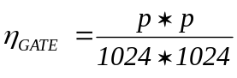
- In the optical gate case, both the raster size and the Analysed area must be correctly calibrated. The raster size is defined as the as the scanned field size, in µm at the sample planein the case of a punctual primary spot. The Max Area is defined as the sample field diameter limited by the largest field aperture the diameter of which is 1800 µm. So, the Analysed area is simply defined as
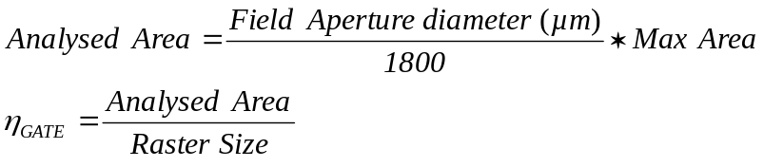

Contents ↑

EM aging
When an EM is getting older the EM gain (output electrons per ion) decreases , leading to a Y_{EM} decrease if the EM HV is kept constant. For recovering the original gain and yield, The EM HV must be increased (See the figure below)
Note that the life time of an electron multiplier depends on the gain and the total number of ions counted (total integrated charge). Frequent high intensity measurements shorten the EM life time.

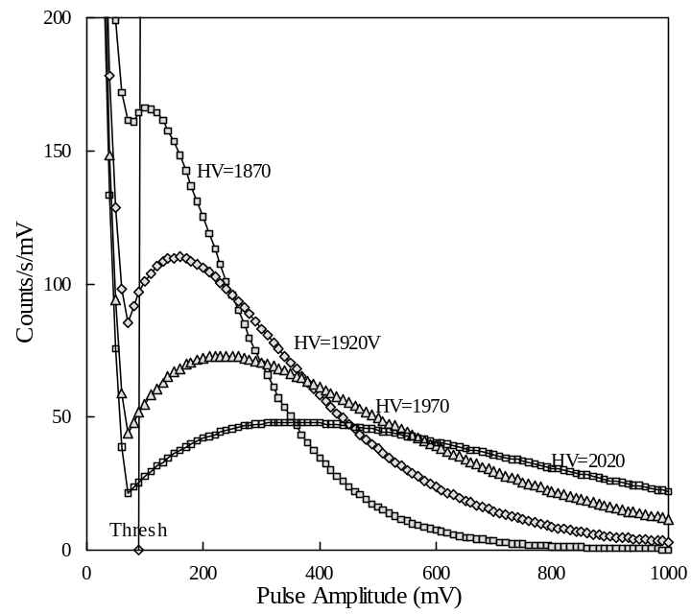 | THE EM PHA  Distribution Curve  The PHA distribution curve is obtained by scanning the discriminator voltage from O to 1000 mV. The obtained curve is then derivated.  Different plotted curves correspond to different EM high Voltages.  The aging effect is equivalent to an EM HV decrease so that the aging must be compensated by increasing the HV Voltage.

Contents ↑

The EM electronic dead time adjustment
The preamplifier / discriminator assembly is shown in the hereunder image. It can be noticed that the preamplifier and the discriminator are independently shielded in order to reduce the electronic noise of the overall system.

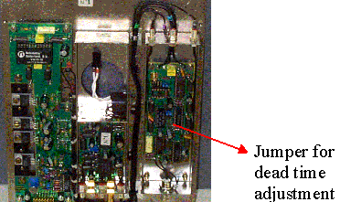

The dead time value is adjustable by positioning a jumper . The available dead time values are : 20, 24, 28, 36, and 40 ns.. The jumper label on the board is TB2. The jumper position corresponding to 20 ns is at the top. The dead time value is the sum of the delay time (determine by the delay line) and the extra time for the signal propagation.

Dead Time = 2* delay_line + 4ns (propagation time)
Dead time (ns) | Delay line (ns) | Jumper position
20 | 8 | 1 (top)
24 | 10 | 2
28 | 12 | 3
36 | 16 | 4
40 | 18 | 5 (bottom)
For most of the applications the jumper position #2 is recommended.

Contents ↑

Switching EM/FCs and FCs/EM
Hard security switching and Soft security switching
During an analysis, the detector may switch automatically from EM and FC in 2 cases
- If the count rate measured within one frame is larger than a Hard security threshold. This Hard security threshold is 2 500 000 counts per sec (cps). As the frame time T_{fr} is 80 ms for the IMS 7f and 4fE7, this corresponds to 1 000 000 count per frame. This is called the Hard security switching. It may be also triggerred during the instrument Tuning. This security is targetted to protect the Electron Multiplier (EM) from an excessive ion bombardment.
- If the instantaneous count rate is larger than (η_{GATE} * soft security threshold). Refer below to the section § η_{GATE} gate rate for more information about η_{GATE}. This Soft security switching is targetted to avoid the beam being measured outside the deadtime correction range. Typically, the soft security threshold must be set to 4000000 cps .

Example: With an electronic gate of 30% (that means that the gate width is 30% of the Raster size), η_{GATE}=0.09, and the soft security threshold set to 4 000 000 cps, the detector is expected to switch as soon as the count rate exceeds 360 000 cps. It will actually switch slightly lower (See below, the EM/FC switching hysteresis).

During an analysis, the detector switches automatically from FC and EM
- If the detector is allowed to switch automatically from FC to EM (refer to the section § The Analysis definition box) and if the instantaneous count rate falls below (η_{GATE} * soft security threshold). This switching is targetted to avoid that the FC channel works in a region (below 500 000 cps) where it is less sensitive than the EM

The EM/FC switching hysteresis

In order to avoid that the switching system (EM, FC) gets unstable whenever the measured signal is close to the soft threshold, an hysteresis effect has been introduced in the thresholding. A hysteresis coefficient is written in the Setup file . | 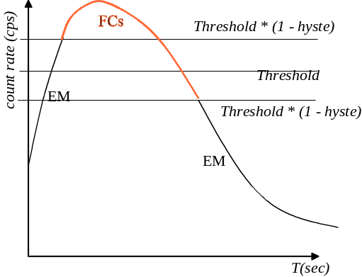

Contents ↑

The Depth Profiling issue

Overview
As it is shown in the figure below, the progressive erosion of the sample gives access to the composition of inner regions. It has been said that the removal of atomic layers by sputtering occurs with the same regularity as the peeling of an onion. However, the erosion disturbs the sample over a thickness which is not infinitely small. This thickness defines the so-called Depth Resolution. According to the primary ion impact energy and other primary ion features like the incidence angle, the Depth Resolution may vary between 1nm and more than 10 nm. Different physical phenomena such as atomic mixing, induced diffusion, recoil implantation or preferential sputtering are involved and will not be discussed in this document. (See Basic SIMS Phenomena)

An in-depth profile is obtained by recording the secondary signal as a function of time; the time scale is then converted into a depth scale by calibration. As a matter of fact, When the crater bottom depth is measured directly with a laser interferometer, the secondary signal is recorded directly as a function of the depth. In fact, each point of an in-depth profile curve corresponds to given slice microvolume of matter sputtered during the point counting point.

Rastered area, Sputtered area, flat crater bottom area, analysed area

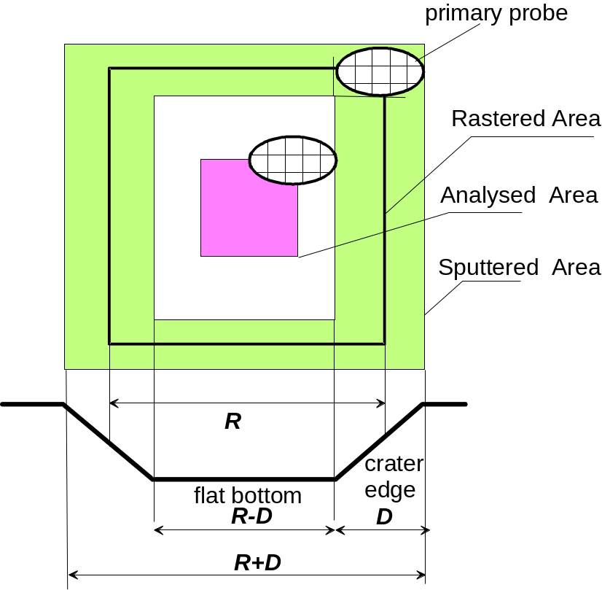

The Rastered Area R is the area which would be sputtered if the primary probe was infinitely small. It corresponds to the Raster value indicated in the Tuning interface and does not depend on the primary probe size.
Let D be the primary probe size. It will be discussed below how D can be precisely defined. Note that one can distinguish Dx and Dy which may be different, but in the following, a single value D will be considered.
The Sputtered Area is all the area dammaged by the primary beam. It is actually the Rastered Area enlarged by the primary beam
The crater flat area is the flat bottom of the crater.
All the above parameters depend only on the ion beam primary setting, probe and raster.

The analysed area is defined by some ion beam secondary arrangements. It must be entirely included within the crater flat area since the measurement must correspond to a given depth. It is explained below that the secondary arrangements used for defining the analysed area may be an optical gate or an electronic gate or both. For each case, a more exact definition is explained below.

Rastered Area | R
Primary probe size | D
Sputtered Area | R+D
Flat Area | R-D
Analysed area (electronic gate case) | R-2*D
Analysed area (optical gate case) | <(R-D)  discussed below

As long as it can be assumed that the primary probe is well-defined (i.e. 100% of the signal is contained within the probe size D) and that the immersion lens has no aberrations, the Depth Profiling issue is rather simple and can be summarized in the table above: Very simple rules allows to determine the analysis parameters: Raster size and gate size. More tricky questions arise from the fact that these assumptions are not met:

Parasitic effects | Optical gate | Electronic gate
immersion lens aberrations | Crater edge influence | No effect
Pimary probe tail or Halo | Analysed area non flat | Analysed area non flatness +  Crater edge influence
Primary spot not centered within the field Aperture (FA) | Analysed area shifted with respect to the crater center. | Tolerant if large FA.  Beam is cut if the spot shift is larger than the FA radius.

Contents ↑

Electronic gating

It is assumed below that the electronic gating is used with the dynamic transfer mode. This allows in most case to avoid cutting the beam by the FA and should lead to a better reproducibility.

Depth profiling with electronic gating is tolerant to immersion lens aberrations.

It must be clear that the so-called electronic gate is actually a time gate and not a spatial gate. The physical area corresponding to the W_{G}xH_{G} electronic gate is actually larger than W_{G}xH_{G}, since it results of the convolution of the W_{G}xH_{G} gate by the primary probe. This leads to the basical relationship, already discussed above:

e-gate size < Raster - 2 Spot size

If the primary spot is not well-defined, for example, if it is assumed to be a gaussian function, the question arises: "Which percentage of primary intensity can be accepted outside the Spot Size as it is defined by the above relationship". This is discussed below as the tail effect.

The tail effect

When a small part of the primary spot intensity is contained in a tail or a halo excceding the expected size , the spot end may lick the crater edge during the e-gate time. This is particularly harmful if there is a large concentration difference between the edges and the bottom as it is the case for multilayer sample, where a species concentration may fall down sharply from 1 to zero. This case is displays below.

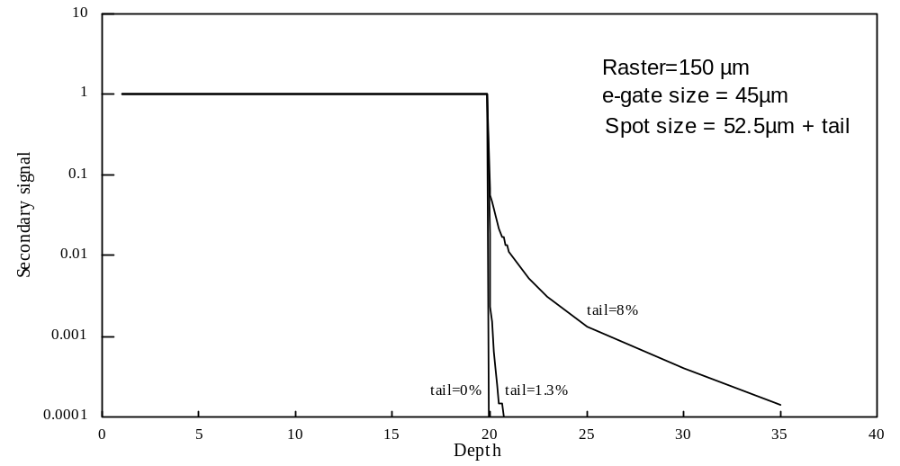

The above figure displays 3 profiles corresponding to different primary spot tails. "tail=x%" means that x% of the primary spot intensity is outside a diameter of 52.5µm. This last spot size is the theoretical maximum spot size corresponding to a Raster of 150µm and an e-gate of 45µm, according to e-gate size = Raster - 2 spot size.

A tail or a halo leads to a loss of dynamic if the e-gate if the overall primary spot size is not taken into account in the e-gate size calculation.

Contents ↑

Optical gating
The optical gating consists of limiting the scanned field with the Field Aperture (FA). Dynamic Transfer (DT) is not involved in the Optical Gating (DT OFF). The hereunder figure displays the FA plane as it would be if the transfer optics had no aberrations. The circular Analysed Area is the Field Aperture and the rastered area is an image of the sample rastered field in the FA plane, as it would be if the primary spot was punctual. The Field of View circle correspons to the largest FA (1800 µm).
It is shown on this figure that the difference between the crater internal boundary and the analysed area boundary must be equal or larger than the overall immersion lens aberration. In the hereunder figure, this immersion lens aberration is larger than the primary spot. In such a case, electronic gating would be more advantageous, but reversively, whenever the immersion lens aberration is smaller than the primary spot, optical gating may be more advantageous than electronic gating.

It is recommended to use always electronic gating for reinforcing the optical gating.

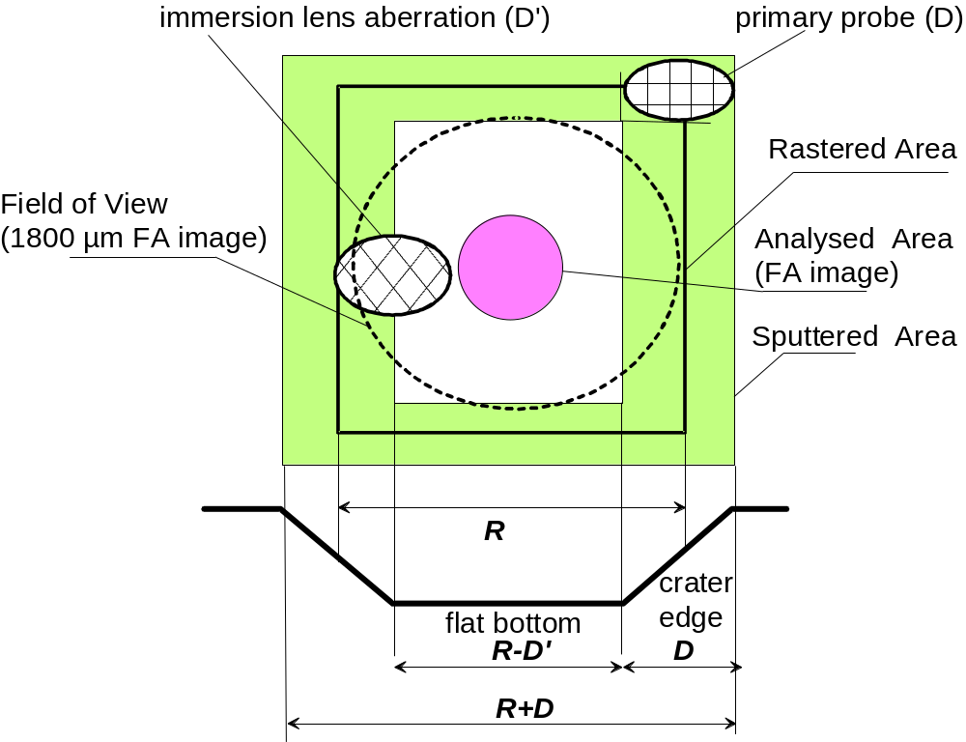

Contents ↑

The η_{gate} gate rate
It is explained in the previous two sections that two different ways may be used for achieving a gating: Electronic gating and Optical gating. It results from both optical and electronic gating, that the instantaneous count rate is not equal to the number of counts per frame divided by the frame time since within a frame all the counts are concentrated within the gated area.
When running a depth profile analysis, it is required to compute the so-called gate rate η_{GATE} for determining both the EM deadtime correction (Refer to the above section § Electron multiplier (EM)) and the switching EM/FC level (Refer to the above section § Switching EM/FCs and FCs/EM).
The ratio η_{GATE} is the area ratio gate/frame, so that N_{C}/η_{GATE} is actually the instantaneous count rate since N_{C} is the count rate averaged over the whole frame while all the counts occur only over the gate.
For determining η_{GATE}, both electronical and optical gate must be considered.
- In the electronical gate case, the calculation of η_{GATE} is quite straight, since the electronical gate is determined as a square of p x p pixels within the 1024 x 1024 frame.
- In the optical gate case, both the raster size and the Analysed area must be correctly calibrated. The raster size is defined as the as the scanned field size, in µm at the sample plane in the case of a punctual primary spot. The Max Area is defined as the sample field diameter limited by the largest field aperture the diameter of which is 1800 µm. So, the Analysed area is simply defined as
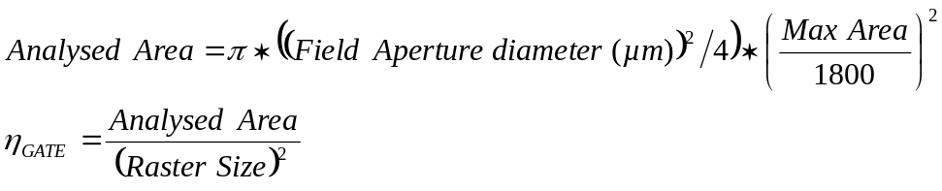

Contents ↑

Controlling the ion optics from the computer

Overview
The IMS 7f and 4fE7 is completely computer controlled. All the settings derived from the procedures described in the user's guide part(1) § Tuning the primary column and Tuning the secondary ion optics can be saved and restored in Instrument Status Files (ISF). The motorized aperture settings are included in the ISF.

As it is explained below a given ISF does not contain a single setting configuration, but all a set of variant. In the following sections, it is explained that within an ISF, some parameters called the Main Analytical Parameters (MAP) cannot be varied while all the other parameters are clustered into a few number of reduced parameters called the Optional Instrument Parameters (OIP) can be varied. A given ISF contains several possible configurations of each OIP. Note that an OIP is roughly equivalent to the so-called presets mentionned in the text.

For running an given analysis, a user must first select a set of MAP deduced from the analysis requirement. For instance, for measuring Arsenic in a Silicon matrix with a high depth resolution, the user will select the Cesium as primary ions, 500 eV as impact energy and a negative secondary polarity. An ISF consistent with these MAP will therefore have to be loaded from the computer disk.
Then, for defining an analysis, the user must precise the instrument conditions by selecting one among several of each OIP while using the same ISF. For instance, He may select Raster= 75µm or Raster 225µm, DT=ON or DT=OFF, FA=1800µm or FA=750µm etc… The OIP allow to describe a complete instrument configuration with a reduced set of parameters.
Some presets are used only for tuning purpose (e.g. Slit or Image). They are not called OIP, but as the OIP, they are also reduced parameters.

It mus be emphasized also that some Instrument parameters do not depend on the MAP. They are not therefore included within the ISF, but stored in a set-up file which will be used whatever the loaded ISF will be.

Detailed information about the user's interface is provided in the Tuning software user's guide.

Contents ↑

The Instrument Status Files (ISF)
The ISF contains 47 primary parameters, 53 secondary parameters and 14 parameters related to the Normal Electron Gun (NEG). Actually, it contains very more than 114 values since whenever a parameter is included in a preset, there are as many stored values as the number of different preset which is generally of 10.
Some functions allow to transform an ISF corresponding to a given set of MAP to another ISF corresponding to another set of MAP:
- VALID + SOURCE HV
- VALID + Sple HV
- VALID + e- HV
These functions are available from the synoptics box. The general procedure for these functions is load XXX.ISF + transformation + save as YYY.ISF.

VALID + SOURCE HV allows to change the primary column acceleration voltage. All the primary parameters updated for the new required Source HV. Refer to the Tuning software user's guide/ Valid Source HV

VALID + Sple HV allows to change the sample voltage that is also the secondary acceleration voltage. All the secondary parameters updated for the new required Sple HV. Refer to the Tuning software user's guide/ Valid Sample HV

VALID + e- HV allows to change the NEG voltage. All the NEG parameters are updated for the new required e- HV. Refer to the NEG user's guide.

Contents ↑

Main Analytical Parameters (MAP) and Optional Instrument Parameters (OIP)
The Main Analytical Parameters (MAP) are listed below:
- The primary ion source (Cs or Duo)
- The primary acceleration voltage SOURCE HV
- The primary ion Impact Energy IMPACT
- The Secondary polarity (+/-)
- The secondary acceleration voltage Sple HV
All these parameters are constant within a single ISF

The Optional Instrument Parameters (OIP) are listed below. All of them have several configurations (presets) contained within a single ISF. They are not switched along a single analysis.
OIP | Number of presets contained within one ISF
Primary beam | 10
Raster | 10
Maximum Area | 10
DT (ON/OFF) | 2
Electronical gate | 10
Entrance Slit (Ent S) | 10
Contrast Aperture (CA) | 4
Field Aperture (FA) | 4
Energy Slit (Ener S) | 10
Exit Slit | 10
The Mass Resolution preset is a super OIP which reduces the set of 3 apertures Ent S, FA, and Exit Slit to a single parameter. Refer to the Tuning software user's guide for a detailed list of the parameters reduced into each OIP.

Other presets
The detection EM and FC presets can be switched along an analysis. The MCP Slit and MCP Image presets are not involved within an analysis. For both, 10 different preset configuration are contained in a single ISF.

Contents ↑

The Set-up files
Some parameters do not depend on the MAP. There is therefore no reason to store them in the ISF. They are stored in a single file called Set-up file.
Some of them are available from the synoptics box. For instance the EM Voltage must be increased all along its own life, according to its aging.
Other parameters can be edited either directly in the Set-up table (Refer to the Tuning software user's guide) or through a Tool. That is the case, for example of the secondary Faraday offset or the percentage of lines which are sampled for the continuous primary beam Faraday measurement. Refer to the Tool software user's guide.

Contents ↑

